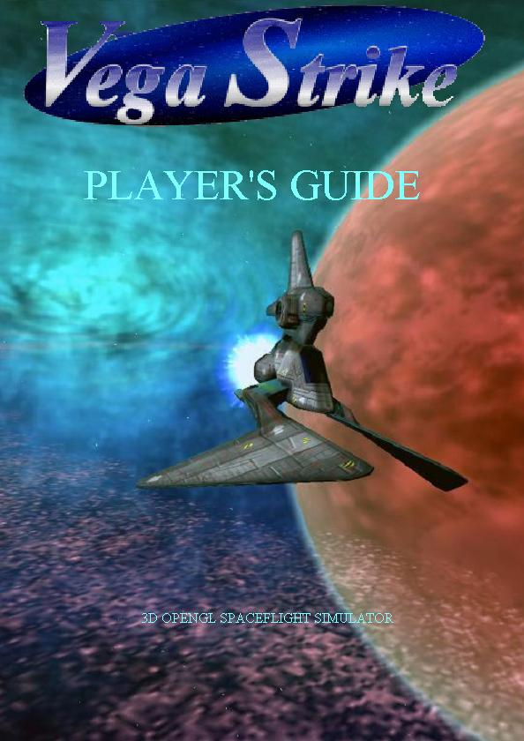

Vega Strike Player’s Guide
Revision 1.3.0
Current for Vega Strike Version 0.7.0

2. Table of Contents
3. Dedication 5
4. What is Vega Strike? 7
4.1 Vega Strike is both a game (universe), and a game engine 7
4.2 Vega Strike is Free (as in liberated) Software 7
4.3 The Game: Vega Strike: Upon the Coldest Sea 7
4.4 Developer Contributions 8
4.5 Introduction 8
5. GETTING STARTED 9
5.1 Basic Configuration Settings 10
5.1.1 Computer 10
5.1.2 Difficulty 10
5.1.3 Sound 11
5.1.4 Music And Volume 11
5.1.5 Video 11
5.1.6 Resolution 11
5.1.7 Color 12
5.1.8 Mouse 12
5.1.9 Joystick 13
6. In-game menu 14
6.1 Multiplayer connection screen 15
6.1.1 LAN / Deathmatch mode. 15
6.1.2 Experimental MMO (online multiplayer) style play 16
6.1.3 Troubleshooting 16
7. ON THE BASE 17
7.1 The Concourse 18
7.1.1 Landing Pad 18
7.1.2 Concourse 18
7.2 Trading Cargo 18
7.2.1 Cargo Computer 19
7.2.2 Cargo Screen 19
7.3 Mission Computer 20
7.3.1 News Screen 21
7.3.2 In Game Missions 21
7.4 Weapons Room 24
7.4.1 Upgrades Screen 25
7.4.2 Player Information Screen 26
7.4.3 Ships Screen 27
7.5 The Bar 29
7.5.1 Bar Attendant 30
7.5.2 Fixers 30
7.5.3 News 30
7.6 In Game Menu 30
8. IN-FLIGHT STATUS CHECK 31
8.1 Basic Flight Training 31
8.2 Advanced Flight Techniques 32
8.2.1 Matching Velocity 34
8.2.2 Docking Procedures 34
8.2.3 In System Transit 35
8.2.4 Autopilot 35
8.2.5 Interstellar Travel 35
8.3 Take a Look Around You 37
8.3.1 Cockpit View 37
8.3.2 Camera View 37
8.4 The Heads-Up Display 38
8.5 Map Screen 41
8.6 Targeting 42
8.7 Communication 43
8.8 Wingmen 44
8.8.1 Commanding Wingmen 44
8.8.2 Hiring Wingmen 44
8.8.3 Cargo Wingmen 45
9. COMBAT 46
9.1 Engaging in Combat with an Opponent 47
9.1.1 Guns 47
9.1.2 Missiles and Torpedoes 48
9.1.3 Inertial Target Tracking System (ITTS) 48
9.1.4 Electronic Counter Measures (ECM) 48
9.1.5 Cloaking Device 48
9.1.6 Tractor Beam 48
9.1.7 Turrets 49
9.2.1 Ejection 49
9.2.2 Self-Destruct 49
9.2.3 Respawning 50
9.3 Miscellaneous Gameplay Functions 50
9.3.1 Quitting 50
9.3.2 Pause 50
10. Resources 51
10.1 Vega Strike Homepage 51
10.2 Vega Strike Forums 51
10.3 Vega Strike Files 51
10.4 Vega Strike Project Page 51
10.5 Online Player’s Guide 51
11. Appendix 1: Tutorials 52
11.1 Tutorial 1: First Arrival 52
11.2 Tutorial 2: Your First Cargo Run 53
11.3 Tutorial 3: Making Some More Money 54
11.4 Tutorial 4: Combat 55
11.5 Tutorial 5: What Next? 56
12. Mods 56
12.1 Vega Trek 56
12.1.1 What is it? 56
12.1.2 Manual Changes 56
12.2 Privateer© Gemini Gold 57
12.2.1 What is it? 57
12.2.2 Manual Changes 57
12.3 Wing Commander© Universe: Privateer© Remake 58
12.3.1 What is it? 58
12.3.2 Manual Changes 58
12.4 Wing Commander© Universe: Privateer© Remake 59
12.4.1 What is it? 59
12.4.2 Manual Changes 59
12.5 Elite Strike 60
12.5.1 What is it? 60
12.5.2 Manual Changes 60
12.6 Wing Commander© Armada: PI Armada 61
12.6.1 What is it? 61
12.6.2 Manual Changes 61
12.7 Vega Wars 62
12.7.1 What is it? 62
12.7.2 Manual Changes 62
13. Copyright Information 63
13.1 Copyright 63
13.2 GNU Free Documentation License 63
14. Quick Key Guide 67
14.1.1 Navigation-Direction Keys 67
14.1.2 Navigation-Speed/Velocity 68
14.1.3 Sound and Music 68
14.1.4 Communication (General/Wingmen) 68
14.1.5 Target-Select 69
14.1.6 Combat 69
14.1.7 Turret(s) 70
14.1.8 Game-Commands 70
14.1.9 Camera-Control 70
14.1.10 Info/Mission/Cargo 71
14.1.11 Miscellaneous 71

3. Dedication
This Player’s Guide is dedicated to Daniel ‘Hellcatv’ Horn and the Vega Strike development team for bringing us the Vega Strike game; to the coders, artists, designers and play-testers willing to devote their own time and effort to the creation of a great game; and of course the players of Vega Strike, without whom this whole thing would be a pointless exercise.

Developers:
Daniel Horn (Hellcatv)
Patrick Horn (Ace123)
Jack Sampson
Klauss Freire
Mike Byron
Ed Sweetman (Safemode)
Daniel Aleksandrow
Stephane Vaxelaire
Alexander Rawass
Sabarok Aresh
Scheherazade
Alan Shieh
Spiritplumber

Artists:
James Carthew
Julien Chateau
Chuck_starchaser
Coffeebot
Cub of Judah's Lion
Howard Day
Esgaroth
f109 Vampire
Fendorin
Jeff Graw (Hurleybird)
Peter Griffin
Fire Hawk
Eliot Lash (Halleck)
Oblivion
Kinnear Penman
Phlogios
Pontiac
Pyramid
RearAdmiralTolwyn
Silverain
Spiner
Strangelet
Balint Szilard
Etheral Walker

Music:
Mike Ducharme
Falik
Peter Griffin
M1ck
Ken Suguro
Zaydana

Web Site Design:
Matthew Kruer
Aazelone Pyoleri (Zaydana)

Packaging:
Vincent Fourmond
Mike Furr
Krister Kjellstroem
Brian Lloyd

Community:
Martin Baldwin
Bgaskey
Dilloh
DualJoe
Eagle-1
Henrik Eklund
Electrotech
Charlie G
Gorruenwe
loki1950
Marcel Pare
Paynalton
Major A Payne
Steelrush
Vortis
Jason Winzenried (Mamiya Otaru)
Tobias Wollgarn
Wolphin
www2
Acknowledgements and thanks:
Sourceforge
Crystal Space
gimp
Blender
NVidia (dds tools)
Open standards
Freedom of speech
User patience
… and any we forgot to mention

4. What is Vega Strike?

4.1 Vega Strike is both a game (universe), and a game engine
Vega Strike is an OpenSource 3d Space Simulator. Work continues on both the Vega Strike game engine and a Vega Strike Universe game data set. Both engine and data are in a playable state (hence a Player’s Guide and not just a development document), but still under development. Each release serves as a beta for both engine and data.
The Vega Strike engine serves as the foundation for the Privateer Gemini Gold, Privateer Remake, Vega Trek, and Pi Armada projects, whose websites can be reached via the sidebar to the right.
The project goal is, at version 1.0, is to be a generic space simulator. Currently developed features include:
  - Trading
  - Exploration
  - Plenty of shoot 'em up action
  - Preliminary multiplayer Deathmatch (testing server only)

4.2 Vega Strike is Free (as in liberated) Software
Vega Strike is an Open Source Software project under the GNU license (with dual-licensed GNU/Creative Commons artwork). We believe that, even in the realm of computer games, it is important that people have access to codebases that will let them imagine, create, and expand on their own terms, not those of some restrictive proprietary license.
- For more information about Free Software and the Free Software Foundation, GNU and their licenses, and Open source or free software in general you can visit http://www.gnu.org/fsf/

4.3 The Game: Vega Strike: Upon the Coldest Sea
Vega Strike: Upon the Coldest Sea places the player in the role of Deucalion, in a mostly sandbox setting featuring Elite-like game mechanics.
As you play, you will see that several species and numerous political entities are present in the game, and they do not all co-exist peacefully. With the invasion of the Union of Dispossessed Colonists,a lesser political entity, the brink of war has been reached between the human dominated Confederation of Inhabited Worlds and the Aeran Ascendancy even as the border between the Rlaan Assembly and the Aera still smolders under a long, tense cease-fire that has failed to become a peace.
- Some player character backstory can be found here: Deucalion's Monologue: (A Dead Man's Ship)

- The Vega Strike Wiki Database contains many entries on the ships, species, and factions found in the VS universe, and is a good starting point for those interested in exploring backstory. The Wiki Database is, however, still a work in progress. Many entries are minimal or in need of significant editing. However, it's still the best (non-developer/non-spoiler-filled) source of information on the VS universe and entities therein.

4.4 Developer Contributions
Would you like to contribute to Vegastrike and become a developer? Great! Just sign up for the developer mailing list (our apologies if it's a bit on the dry side, the deluge of spam really gunked things up for a while and recovery has not been swift, with many developer communications moving to alternate channels) and send us an email about youself, noting your skills (or which ones you'd like to develop by working with us ;-) ) and what you would like to do. Or, go to the forums and developer blog and poke around until you find someone working on something that interests you and contact the people working on that aspect of the project directly. YOU DO NOT HAVE TO BE A CODER! We have a profound need for people to do many other things as well -- documentation, web maintenance, fiction development, artwork etc. Believe us -- we'd kill for people with good cat-herding skills even if their skillset doesn't include anything technical (Scatter-brained academic code-developers attempting to remote manage busy artists, artisans, and even each other doesn't politely lend itself to the smoothest operation one can imagine).
If you would like to help, or would like to find out more about the project first, then go to our forum and ask any questions you might have, what you can do, what needs to be done, etc.

4.5 Introduction
We, the developers, welcome you to Vega Strike, a 3D OpenGL space-flight simulator developed for multi-platform play.

Vega Strike allows players to explore a vastly dynamic universe where frontiers collide and you're just a pilot trying to make ends meet. How? That's your decision. Vega Strike is designed as a non-linear gaming experience, where you choose what action you want to take.

Vega Strike features a trading economy, allowing your character to operate as a merchant. Discover what trade routes bring in the most profit, what commodities make you the most money given your ship's cargo space limitations, accept cargo missions and learn to avoid areas of danger (repairs do eat into profits!).

If you tire of making money on milk runs, or just want to try something different, then there are other paths to success. Vega Strike features a mission generator, providing multiple missions to the experienced (and not so experienced) pilots. Engage in bounty hunts, patrols, battles and escort missions. Feel like traveling? Explore the dynamic universe and see the farthest reaches of known space. Want a walk on the wild side? You could always turn pirate! Just be prepared for the consequences.


Your ship just not doing the job you want it to? Vega Strike gives you the ability to purchase from a wide variety of ships capable of doing different jobs. Want to haul cargo? Fight battles? There's a ship for you. Your ship is fully customizable, so if you've got the credit, outfit your craft with the right tools for the job at hand.

Have a chat to the bartender or view the news broadcasts to find out what's going on in the universe. While you're there, talk to the fixers, they may have a job that only you can do. But be warned, you never know where it may lead...

Vega Strike: Winner of the Jeux (games) category of the Trophees Du Libre 2003.

5. GETTING
STARTED

5.1 Basic Configuration Settings
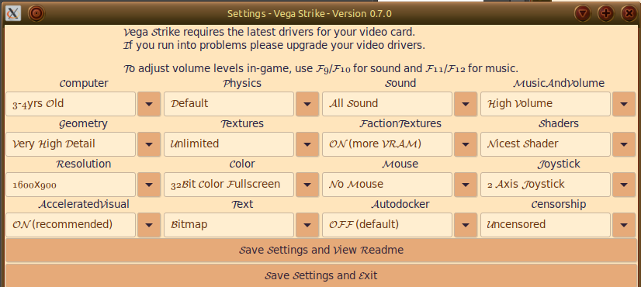

The Game Settings Screen

5.1.1 Computer
FIXME appears to be an abstraction of dedicated graphics
- Old/laptop or integrated GPU: no graphics card, or limited VRAM
- 3-4 yrs old: FIXME
- 2-3 yrs old: FIXME
- 1-2 yrs old: FIXME
- Current: FIXME

5.1.2 Physics
FIXME

5.1.3 Sound
Determines what generates sounds in Vega Strike.

Note that Linux Sound settings are for Linux. The others are Windows settings. The volume level in Linux drops off at a different rate.

- "No Sound" - No sound files played. Recommended when game performance is slow.
- "My Sound Only" - AI sound is deactivated; Sounds originate from you and your ship only.
- "My Linux Sound" - AI sound is deactivated; Sounds originate from you and your ship only.
- "All Sound" - AI sound is activated
- "All Linux Sound" - AI sound is activated

5.1.4 Music And Volume
This is the initial setting for your music volume. This setting can also be adjusted in game.

- "High Volume" - To give you loud, dramatic music!
- "Medium Volume" - For enjoying the music but without it being intrusive.
- "Low Volume" - Suitable setting for having music playing in the background.
- "Music Off" - To turn off music. Recommended on systems with not much RAM.

5.1.5 Geometry
This selection determines the level of visual detail Privateer Remake projects to your monitor. These settings affect smoothness and rounding of objects, font style and anti-aliasing, sun halos, maximum texture size capability and whether reflection capability is available.

- "Extreme Detail"
- Highest detailing available including full smoothing, halo, texturing and reflection capability available. Cockpits can be activated. Only higher-end video cards should use this setting without performance consideration.
- "Very High Detail"
- The main difference is a large reduction in the level of visual detail.
- "High Detail"
- Further reduction in visual detail, and reduced lighting capability.
- "Medium Detail"
- Visual detail reduced with nebula fog disabled.
- "Low Detail"
- Low visual detail with minimal texture detail. Light reflection is disabled with no halo effects.
- “Retro Detail”
- This is intended for users with Software drivers (i.e. rendered without using the graphics card) You will need this if, in Low Detail, the suns have holes. Also, this runs at a resolution of 640x480 regardless of the resolution setting.

5.1.6 Textures
FIXME

5.1.7 Faction Textures
FIXME

5.1.8 Shaders
This section refers to shader quality, in a range from “no shader support” to “extreme shader” FIXME: explain options in greater depth

5.1.9 Resolution
This selection sets the Video Resolution for Vega Strike to use. It should be set to equal or slightly lower than your normal screen/monitor resolution.
Vega Strike will adjust for the Aspect Ratios according to whether you select a widescreen resolution (e.g. 1280x800), or a 4:3 resolution (e.g. 1024X768)
Please note: the larger the resolution, the more processing power is needed.

5.1.10 Color
This selection determines whether the game uses the 32-bit (millions of colors) coloration or 16-bit (thousands of colors) color range. Note that on old systems, 16-bit may be significantly faster.

It also determines whether the game runs in Full-screen mode (uses your whole screen, limited by your resolution setting) or is Windowed (appears in a window on your monitor allowing you access other programs, but smaller in size).

5.1.11 Mouse
This selection determines your mouse control during flight operations.

- "Mouse Warping"
- Your craft turns in the direction of the mouse movement, but the turn only continues while you mouse moves. To continue a turn, you need to continue scrolling your mouse in the desired direction.
- "Inv Mouse Warping"
- inverts the direction of "Mouse Warping"
- "Mouse Glide"
- Provides a 'ghost' targeting reticule that is movable around the screen. When moved away from the center, your ship will turn in the direction of the reticule. Re-center the reticule to cease turning. This option does not require continually moving the mouse to continue a turn.
- "Inv Mouse Glide"
- inverts the up/down direction of "Mouse Glide"
- "No Mouse"
- No mouse flight.

Mouse Default Button Settings
- Left Click = Fire Weapon
- Middle Click = Fire Missile
- Right Click = Afterburner
- Scroll Up = Target (cycle all available targets)
- Scroll Down = Target (target nearest targeting reticule)

The rest of the actions (counting from 0), may depend on your Mouse configuration.
If you have configured your mouse, you can also use:
- button 5 = Deceleration (decrease speed)
- button 6 = Perform a Shelton Slide
- button 7 = Acceleration (increase speed)
- button 8 = Cycle through guns
- button 9 = Cycle through missiles

5.1.12 Joystick
This selection configures your joystick for flight control. These are the default settings for the joysticks:

- "No Joystick"
- No joystick flight enabled.
- "2 Axis Joystick"
- Enables a standard 2 axis (x,y) joystick with two buttons (0,1).
- "2 Axis Joystick And Throttle"
- Enables movement in the x,y directions only. Throttle control over your set speed.
Two buttons (0,1).
- "3 Axis Joystick"
- Enables movement in all three directions.
- "3 Axis Joystick and Throttle"
- Enables movement in all three directions, plus the use of a throttle. Currently, throttle control gives acceleration and deceleration, not speed control. Result: set speed is either maximum or zero.
- "Joystick and Throttle Reversed"
- Reverses the setting of third axis and throttle.

Joystick Default Button Settings
- x axis = changes direction of pitch. Imagine holding your arms out sideways from your body and your hands holding on to something. You then swing your feet up and down. You are rotating on your arms (x axis).
- y axis = changes direction of yaw. Imagine standing upright, then turning in place to the left or right.
- z axis = changes direction of roll. Imagine standing upright, holding on to a pole above you running from forwards to backwards. You then swing from left to right. You are 'rolling' around the pole.

- button 0 = Fire Weapon
- button 1 = Afterburner
- button 2 = Fire Missile
- button 3 = Target (cycle all available targets)
- button 4 = Target (target nearest targeting reticule)
- button 5 = Deceleration (decrease speed)
- button 6 = Perform a Shelton Slide
- button 7 = Acceleration (increase speed)
- button 8 = Cycle through guns
- button 9 = Cycle through missiles

If you want to change these settings, the joysticks can be programmed directly by direct editing the vegastrike.config file – you can find more information here:
http://vegastrike.sourceforge.net/wiki/Manual:Config:Advanced:Bindings:Joystick
If you don't want to do this yourself, or you need help, ask at the forums:
http://vegastrike.sourceforge.net/forums/

5.1.13 Accelerated Visual
FIXME

5.1.14 Text
FIXME

5.1.15 Autodocker
FIXME presumably an AI feature for autopilot while docking

5.1.16 Censorship
This section refers to the presence or absence of some splash screens that some players may find in questionable taste.
- Censored: clean splash screens only
- Uncensored: questionable splash screens enabled

6. In-game menu

Upon starting up Vega Strike, you will see the following in-game menu:

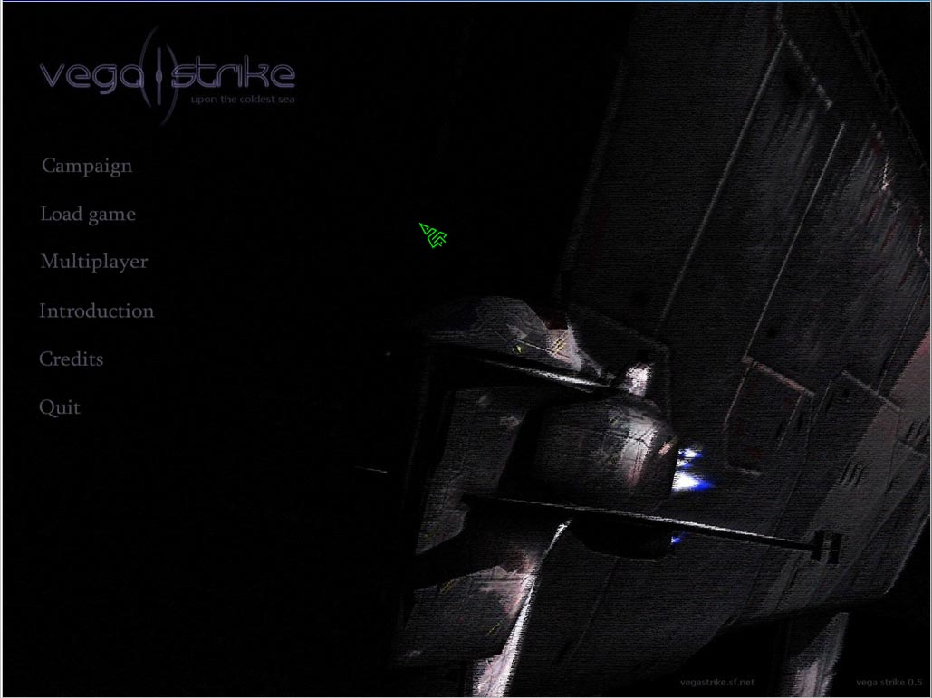

- Campaign
  - Start a new Vega Strike game from the beginning.

- Load game
  - Restore a previously saved game.

- Multiplayer
  - Bring up the multiplayer connection screen

- Introduction
  - Read Deucalion’s (the player character) intro monologue.

- Credits
  - See the credits and acknowledgement page for developers and contributors to VS

- Quit
  - Exit Vega Strike

6.1 Multiplayer connection screen

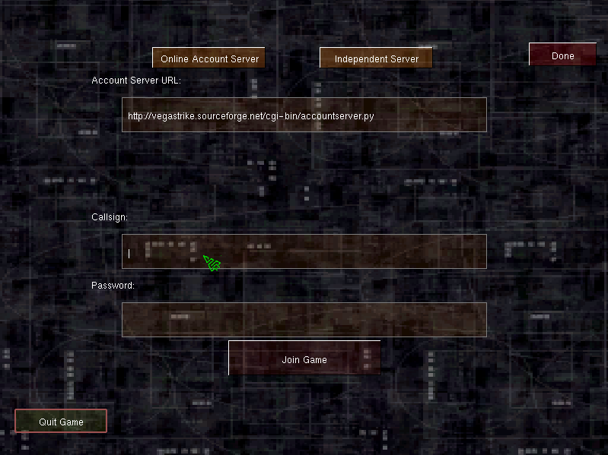
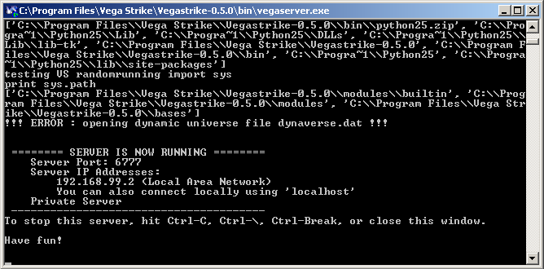
Multiplayer currently has two modes:

6.1.1 LAN / Deathmatch mode.
Starting a game
To play a LAN game in deathmatch mode, you must run the "vegaserver" program separately from Vega Strike.

The terminal window (to the right) will show connection information. You can now connect to the server.
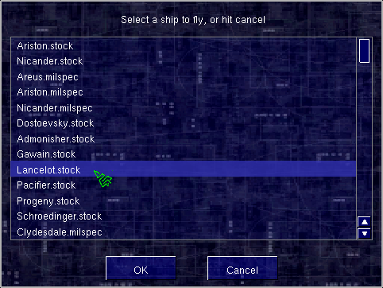
Joining a game
In Vega Strike, click on "Independent Server". If you are connecting from a different computer, you must type in the "IP Address" of the server you are connecting to, and type in any callsign.
If the server is set up with the "server_password" variable, you should type that in here.

At the ship selection (to the left), I recommend choosing a “stock” ship. When you join the game, you can hit [d] to dock to the Market planet, and from there you can upgrade your ship and add weapons. Note that you cannot save in this mode.

6.1.2 Experimental MMO (online multiplayer) style play

This style will act like Single Player mode, but will allow you to interact with other players. Also, be on the lookout for the Public Terminal near the top of bars, where you will be able to register bounties on other players, among other things.

To connect to a server, click on Multiplayer, and in the Online Account mode, type in your username and password.

Register for an account by signing up with a forum user: http://vegastrike.sourceforge.net/forums/

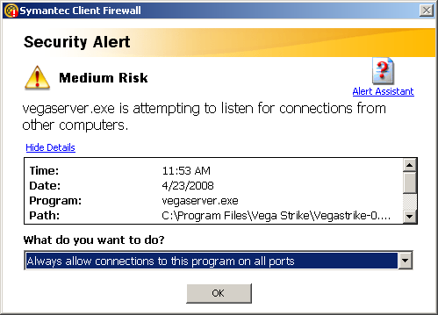
6.1.3 Troubleshooting

As always with internet applications, make sure your firewall settings allow connections to your server and to Vega Strike. Be prepared to answer a series of questions like the one to the right when starting your server, or when clicking “Join Game” inside of Vega Strike

It is also in late alpha, so please report any bugs you find (we know they're there).
In addition, be aware that the servers may have significant downtime. Do not be surprised if you get an error message.

If you would like to run your own server, consult the wiki or ask on the forums for more information. A full server requires an account server to save your game can be found in the “cgi-accountserver” folder, and requires a full installation of Python to run.

7. ON THE BASE
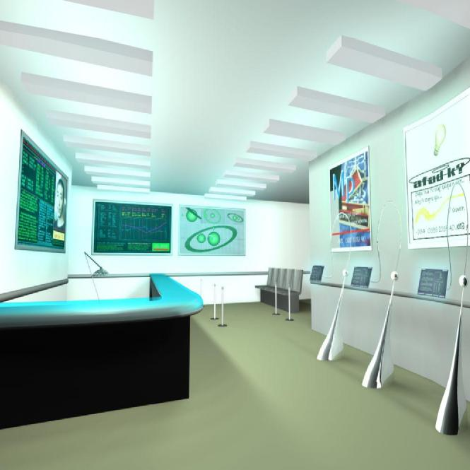

As you read through this manual, you will note references to various keys. These key references appear within brackets e.g. [w] refers to the w key; [W] refers to the capitalized letter. [CTRL+w] refers to pressing both the Control and w key simultaneously. References to [KP] refer to using the buttons on the keypad. Buttons appearing onscreen are noted in a similar fashion.

7.1 The Concourse

7.1.1 Landing Pad
On first starting Vega Strike, the first in-game screen you will see is the Landing Pad. On first landing at a base, the Landing Pad will usually be your first view of the base. Note the ship located in the foreground. This is your current ship. At the beginning of play, this ship is the Llama; a good, general all-round cargo hauler capable of defense and limited offense.
The Landing Pad is the player's portal into the base, and is the screen to be in when intending to launch from the base.
The Landing Pad serves two functions:
- Access to the base. Moving the cursor will eventually highlight the Concourse exit. Clicking on the location highlighted will take you to the Concourse screen.
- Launching. The Landing Pad displays your current ship. To launch into space, double-click the left mouse button on the ship.

7.1.2 Concourse
On arrival at a base, station or planet, most pilots will want to perform any number of various functions. These functions include browsing for new missions, replacing or upgrading weapons and ships, trading any cargo they happen to be carrying in their holds, or just having some rest and recreation. The Concourse serves as the primary interface to all other base locations. A newly arrived pilot can find it all starting from the Concourse.
The usual locations are:
- Cargo Computer - to buy and sell cargo.
- Mission Computer - to select missions and view the latest news.
- Weapons Room -to upgrade your ship, purchase a new ship and view character information.
- The Bar - have a drink, chat to the locals and view the latest news.

You may also find uncommon and rare locations, viewable just for the scenery or which may have bearing on a mission you might be undertaking…
Lastly, be aware that some bases integrate the Landing Pad with the Concourse. Where this is the case, all operations can be performed in the Concourse.

7.2 Trading Cargo
One of the main aims of a Vega Strike pilot is to make a profit. While there are several different ways in which to do so, we consider here the ability to make a profit from buying and selling cargo that you transport.
In the Vega Strike dynamic universe, a single merchant pilot with a small amount of credit and a good ship can try to make money trading cargo. This is usually accomplished by buying from their current location, and then delivering it to a destination that is far away, has a need for it, or preferably both. Another way to make money as a merchant is to accept Cargo Missions, which pay a premium for delivering specific cargoes to specific destinations (these missions are covered elsewhere).
The secret to maximizing profits is to learn where a commodity is produced at a low cost, and where that commodity can be delivered for a high price. The use of common sense is recommended for determining what likely trade routes for various cargoes are. For example, a common trade run is to buy raw materials (gems, metals and suchlike) from mining locations (Asteroids) and deliver them to places that can use them (refineries, factories and industrial planets).
The key is to determine what trade routes and what cargoes provide the most profit -and the only way to work this out is by actually transporting cargo. When you are looking at the various cargoes at a base, have a look at the prices listed for other cargoes. You may well discover a new trade route if you're careful!
Lastly, pay attention to the news broadcasts. While the news is often full of battles, the occasional nugget of information will surface. These news reports often note shortages of goods in specific locations, or surpluses of goods in other locations. As you would expect, surpluses will result in a lower price and high availability of the cargo, and shortages in the reverse. Of course, making a delivery may be a problem…
Just imagine the profit you make if you discovered a good trade route, and the news reports had a surplus of cargo where you need to buy, and shortage where you need to sell!

7.2.1 Cargo Computer
To be able to trade cargo, you must have access to a Cargo Computer. Locate the Cargo Computer by moving your mouse cursor around the Concourse until it is highlighted and the name appears at the bottom of your screen (you may not find one, as not all bases have the access required. The Cargo Screen may be accessible from the Mission Computer in this case). Once this occurs double-click to activate the computer. Your view will change to the Cargo Screen.

7.2.2 Cargo Screen
The Cargo Screen, as with all other computer screens, will have the following across the upper viewing area: the title 'Cargo Dealer', followed by the type of your current base location, with the owner's name in brackets beside it. Below that your total available credits are shown. Beside your credit record is a record of your cargo hold showing total cargo volume of the hold and cargo volume remaining after cargo and upgrades.

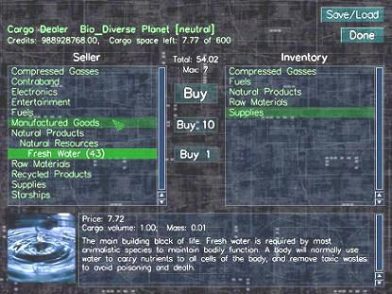
The Cargo Screen
Do not be alarmed if you have no cargo on record, but cargo space available appears as less than your total cargo hold. There are two reasons for this. Firstly, ship upgrades not attached to the ship take up room in your cargo hold. Secondly, if you have failed a cargo mission, you may still have the cargo, but as it is mission cargo, it is not available for general resale. To clear failed mission cargo, refer to instructions on ejecting cargo.
In the top right corner of the Cargo Computer are the [Save/Load] and [Done] buttons. The [Done] button exits the Cargo Computer.
In the center of the screen are two large boxes, separated by three small buttons in between. These are the Cargo Purchase (left) and Cargo Sale (right) boxes. To operate, select (highlight) a category of cargo. Each category opens out into a selection of cargo, and/or further subcategories of cargo.
Continue selecting until your required cargo is highlighted. The three central buttons will now show as [Buy/Sell], [Buy/Sell 10] and [Buy/Sell 1] -they show buy if you are highlighting in the left box, and sell when in the right box.
[Buy/Sell 1] transacts 1 unit of highlighted cargo each time.
[Buy/Sell 10] transacts 10 units of highlighted cargo at one time.
[Buy/Sell] transacts all highlighted cargo. Each transaction moves the transacted cargo from one box
to the other.
Total: displays the total cost to purchase, or total cost of what you are selling.
Max: displays the total cargo you may purchase where cargo space is less than amount available. Total cost is then limited to maximum number by purchase price.

The box at the bottom of the screen displays cargo specific information. At bottom left is a picture of the selected cargo, while the large box generally includes the name, price, mass, cargo volume and description of the cargo. When selling cargo, the description box displays both the purchase and sale price. This allows a quick determination of any possible profit on the trade.
Different planets or bases will have different prices and quantities for groups of items. For example, Mining Bases will have cheaper minerals.
IMPORTANT! Do NOT purchase from the "upgrades" or "star ships" categories in the Cargo Screen if you want to buy a ship for piloting or to upgrade your current ship. Any trading from this screen will place those items in your cargo hold, not install onto or replace your current ship.

7.3 Mission Computer
On arrival at a base, station or planet, most pilots want to perform a number of various functions. These functions include browsing for new missions, replacing and upgrading weapons and ships, and lastly, trading any cargo they happen to be carrying in their holds.
We focus here on the Mission Computer. To review any available missions or get an update on the news, you must have access to a Mission Computer. Locate the Mission Computer by moving your mouse cursor around the Concourse until it is highlighted and the name appears at the bottom of your screen (you may not find one, as not all bases have the access required. The News Screen is also accessible from the Bar). Once this occurs double-click to activate the computer.
The Mission Computer will have the following across the upper viewing area. In the top left will be two buttons marked [News] and [Missions]. If either or both don't appear, that means the base where you are located does not have access to that function at that time. These buttons provide access to the News Screen and the Missions Screen respectively. By default, the News Screen will appear when the Mission Computer is accessed.
Below these buttons is the GNN News banner. Beside the banner is the name of your current base location, with the owner's name in brackets beside it.
In the top right corner of the Mission Computer are the [Save/Load] and [Done] buttons. The [Done] button exits the Missions Computer.

7.3.1 News Screen
No civilization operates in a silent void. Whether passed on as gossip, town crier, old fashioned print or the most modern of holo-vid casts, notice of what's happening around the universe is always welcomed.
Most holo-vid casts provide the most basic of information, and are normally not of that much use to a pilot on the make. Keeping an eye on the news can, however, result in gains when a pilot stays well informed. Knowing of trade opportunities as soon as they occur, local hotspots and the overall status of any wars may well influence just what you choose to do next.
News articles come in three different categories:
- War Reports - Blockades, battles, fleet battles, ships destroyed and suchlike are reported here.
- Trade Information -these articles contain information influencing the prices and availability of cargo for a short period of time. Whether buying cheaply, or selling at an inflated price, this news only has a short lifespan before someone, somewhere takes advantage of it.
- General News -general articles about the universe around you. Politics, the environment, and other subjects may interest you. Sometimes, precious nuggets of information may become available.

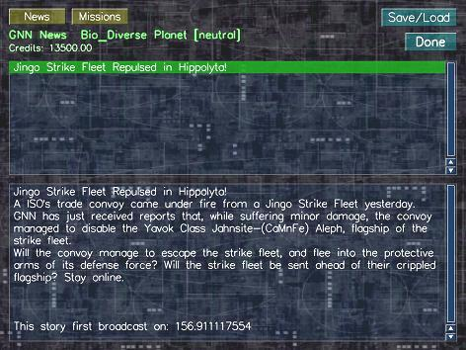
The News Screen

On accessing the News Screen, two boxes will appear one above the other. The upper box contains the article title for each item of news produced. All news produced since the current game was started is accessible from this box.
To read a news article, highlight the relevant title. The body of the news article will now appear in the lower box. The Broadcast Date and Time will then follow the body.

7.3.2 In Game Missions
One of the main aims of a Vega Strike pilot is to make a profit. While there are several different ways in which to do so, we consider here the ability to accept missions that require the Vega Strike pilot to perform a mercenary duty for reward.
In the Vega Strike dynamic universe, mercenaries with a good ship -and better upgrades! – can make a living from being better than their opponents. If a merchant's milk run is not for you, your place is here! Whether you're interested in tracking down criminals for bounty, defending or attacking a nominated target, performing escort duties or patrolling the local systems, we have the job for you. If the job's too tough, hire wingmen! The merchants aren't forgotten either. Take a cargo mission to a distant base for a premium, and then fill your cargo bay with more cargo for delivery. Even a mercenary may want to take a cargo mission once in a while, just to deliver a cargo near your target, and use the credit for that last upgrade before you do battle!
Vega Strike has the ability to provide a pilot with missions in two ways: firstly by accessing the Mission Computer and selecting a mission; secondly by talking to fixers in the Bar.
The Mission Computer posts standard missions with a comparatively low level of reward. Multiple missions can be accepted, but don't take too many. If a pilot doesn't fulfill a mission in a reasonable timeframe, you'll lose the mission, and your reputation with the faction will suffer too.
The rarer, more profitable missions can be obtained from fixers located in bars across the known universe. From off-duty military personnel, merchants, to smugglers and pirates, someone, somewhere, has a job for you. These missions are more dangerous, more intense and -more to the point -rewarding than BBS missions. You'd better be careful though, some missions may lead you where you didn't plan to go, and you may have bitten off more than you can chew...

Lastly, pay attention to the news. Those broadcasts aren't just eye candy. You want to know where the hottest spots are; you want to know how you can make a difference in the war (for a modest fee); or you're engines are shot, weapons are down and you just want to be left alone to heal; well, GNN does have some usefulness.
Mission Types
- Cargo missions have you transport goods to another destination.
- Bounty missions ask you to hunt down and frequently kill a target.
- Escort missions want you to escort a ship from you present location to somewhere else, defending it from any and all attacks.
- Defend missions pay you to attack or defend a static target.
- Patrol missions have you patrol or scout some places in a certain system.
- Wingman missions allow you to hire wingman.
- There are sometimes other missions, which you will need to review closely to determine what is required.

Once you have accepted a mission, the mission objectives appear in your cockpit screen. As you complete an objective, the color will change. Once you have completed a mission, a communiqué will appear notifying that credits have been added to your account.
A total of three (3) missions may be accepted via the Mission Computer or from fixers.
Mission cargo remains in your cargo space until the mission is completed. If you need to remove the cargo, return to space. Select your cargos manifest using [w], and use [PGUP] or [PGDN] to ensure the mission cargo appears topmost. Use [Z] to eject the topmost cargo. If you have a Tractor Beam, you may then tractor the mission cargo back into your hold as standard, sellable cargo.
Accepted missions are not saved within a Saved Game. Therefore, you will need to perform a mission on acceptance. (ED: we recommend saving your game before accepting missions, as this will then allow you to reload a game, canceling any missions previously accepted).
Missions Screen
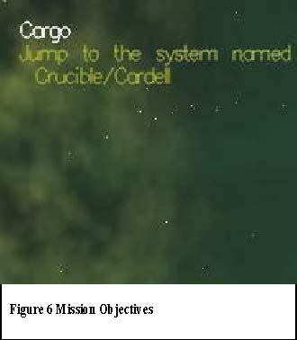
If you are interested in flying missions for reward, you need to access the Mission BBS Computer to see what's on offer. To do so, you must be docked at a base. That base will need to have a Mission Computer available. Some bases may not have a dedicated Mission Computer, but you may be able to access them from another computer which has a Missions button.
To review and select missions, follow these steps:
- Click on the [Mission BBS] button. This takes you to the Missions Screen and displays a list of available mission categories.
- Click on the category name to expand and list specific missions of that type.
- Highlight a specific mission to read the details in the box to the right.
- Select the highlighted mission by clicking on the [Accept] button at the bottom of the screen. You will note that your Active Missions will have increased by one.
- Once you have selected you missions, exit the screen via the [Done] button.

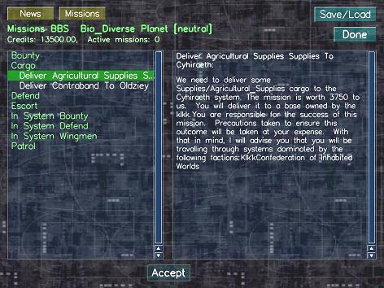
The Missions Screen Bulletin Board Service (BBS)

Aborting a Mission

If you feel you are unable to complete a mission, you may abort the mission.

To do this, go into the “Active Missions” category on the left, and click the [Abort] button at the bottom. However, you will not be offered that exact mission again.

Fixers
If the base has a bar, go on in and treat yourself to some rest and recreation. While you're there, check out who's seated at the tables. People of all walks of life may want to talk to you. If you're interested, click on them to hear what they say. After they have finished, a [Yes] / [No] choice box pops up. If you’re interested in what they have proposed, indicate your decision by clicking the appropriate response.
Fixer


7.4 Weapons Room
On arrival at a base, station or planet, most pilots want to perform a number of various functions. These functions include browsing for new missions, replacing and upgrading weapons and ships, and lastly, trading any cargo they happen to be carrying in their holds.
We focus here on the Weapons Room. To access upgrades, player information or ships available for purchase, you must have access to a Weapons Room. Locate the Weapons Room by moving your mouse cursor around the Concourse until it is highlighted and the name appears at the bottom of your screen (you may not find one, as not all bases have the access required). Once this occurs double-click [LMB] to enter. Inside the Weapons Room, locate and access the Upgrades Screen as above.
The Upgrades Screen will have the following across the upper viewing area. In the top left will be three buttons marked [Upgrades], [Info] and [Ships]. If any of them do not appear, that means the base where you are located does not have access to that function at that time. These buttons provide access to the Upgrades Screen, Player Information Screen and the Ships Screen respectively. By default, the Upgrades Screen will appear when the Upgrades Computer is accessed.
Below these buttons is the screen title, followed by the name of your current base location, with the owner's name in brackets beside it. Below that your total available credits is recorded. Beside your credit record is your cargo hold showing total cargo volume of the hold and cargo volume remaining.
In the top right corner of the Mission Computer are the [Save/Load] and [Done] buttons. The [Done] button exits the Mission Computer.

7.4.1 Upgrades Screen
In Vega Strike, every can be customozed to some degree

The Upgrades Screen allows the player to access, view, buy and sell any and all upgrades capable of being placed on a ship. From attaching extra navigational aids such as overdrives, maneuvering jets and thrusters, to more powerful power plants, shields and weapons, if you have the credit, the dealer (may) have the upgrade.
That is, not all dealers stock the same types or amounts of upgrades. Some upgrades are only available in certain locations (military upgrades for military ships is a good example). Also, your ship has a limited amount of space available for upgrades. A light ship may be restricted to small reactors and light weapons only.
For information on what you can outfit on your ship, and descriptions of the upgrades themselves, refer to the online Database at http://vegastrike.sourceforge.net/wiki/Database

Using the Upgrades Screen
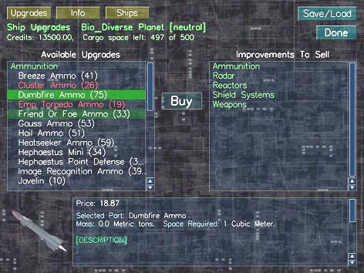
The topmost section of the Upgrades Screen reveals your current docked base's information. For example, the screenshot states you are on a bio-diverse planet operated by the neutral factions.
In appearance, the Upgrades Screen has three view-screens, two placed side by side in the center of the holo-vid, with the third view-screen at the bottom. Note that the view-screens have slider bars where information is greater than can be viewed in one view-screen.
The left view-screen is titled Available Upgrades. This view-screen lists all upgrades currently
available for purchase and installation onto your current ship. Upgrades are arranged in categories, some of which are then divided into sub-categories -for instance, the Shields category divides into Light, Medium and Heavy Shield sub-categories, within which are located individual shield models.
Upgrades marked in colors cannot be installed to your current ship at this time. Yellow denotes a lack of funds, purple a lack of upgrade space, and red a conflict (too many of that type already installed, or otherwise incompatible). When marked white, the upgrade may be installed.
Note that upgrades marked Add (e.g. Add Capacitance) allow you to purchase additional amounts of that upgrade.
Lastly, this view-screen allows the player to repair a damaged ship by selecting and buying [Basic Repair]. This function repairs the basic ship type currently held. It does not, however, replace destroyed upgrades, nor repair them.
The right view-screen is titled Improvements to Sell. This view-screen operates similar to the Available Upgrades view-screen with respect to category selection. This viewscreen lists all upgrades currently installed on your ship. You may choose to sell any and all such upgrades – a necessary function where you replace an upgrade with a more powerful model.

To make a selection, click on the category and/or subcategory in the respective screen. Then, highlight the model you wish to buy or sell. Note that when you highlight an upgrade, a [Buy] or [Sell] button appears between the two view-screens. Click this button to enact the transaction.
The third view-screen provides statistical data, pricing and a description of the current upgrade highlighted. If the upgrade highlighted is one for sale, the price of purchase as well as sale price is displayed.
In the top right corner of the Mission Computer are the [Save/Load] and [Done] buttons. The [Done] button exits the Mission Computer.

7.4.2 Player Information Screen
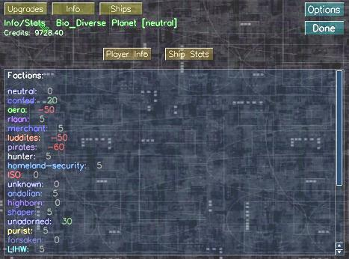
This screen provides information relating to the player. On display at the top of the screen are two buttons, [Player Info] and [Ship Stats]. Pressing either button brings up a viewscreen containing information on factional relationships and current ship statistics respectively.

Player Info
This view-screen lists all the factions that may be encountered in Vega Strike. Each faction listing has a reputation rating ranging from positive (green, allied) down to negative numbers (red, enemies), with several other ratings in between. The second number recorded is the number of faction ships destroyed by the player. Lastly, a tally of Total Kills is recorded at the bottom of the view-screen.
This information can also be accessed in space via the Map Screen.

Ships Stats
This view-screen outlines the statistics of your current ship. Information pertaining to armor, shields, weapons and maneuverability is recorded for your review.

7.4.3 Ships Screen
In Vega Strike, not every ship (and not every pilot) is the same. Whether you're a rookie pilot just starting out; a merchant needing a large cargo vessel; or a bounty hunter after a high performance fighter, everyone at some point wants to replace their current ship with something better suited to what they're now doing.
The Ships Screen allows the player to access all of the various ships available within Vega Strike. Light to heavy ships, produced by all the shipyards of all the various factions may be available -for a price.
Not all dealers stock all available ships. Some ships are only available in certain locations (military ships at military bases are a good example). Also, your reputation with both the manufacturer and the base you are docked with may influence availability.
Ship Types
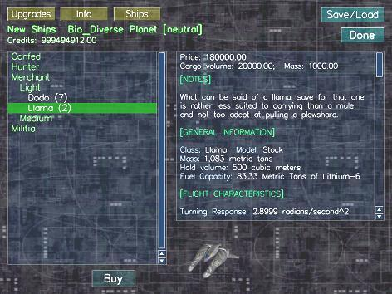
Vega Strike offers several different ships, each available in varying condition. These are:
- Stock: This purchase
provides only the basic
hull. Only the minimal upgrades needed to be spaceworthy are installed.

- Milspec and other variants: A milspec ship
is partially outfitted. It
comes with certain
upgrades permanently
attached. Milspec ships
are notorious for their
difficulty in accepting
upgrades. However, they often offer capabilities that cannot be matched by upgrading a stock vessel.

Purchasing New Ships
The Ships Screen display shows two view-screens. The left view-screen is the Ship Selection view-screen. Ships are organized in categories, based on the factions that produce ships. They are then sub-categorized as light, medium or heavy classed. The right view-screen is the information screen, displaying information on the highlighted ship.

To select a ship, click on a category then click on a subcategory to bring up a list of ships of that type. Ships marked in red are either unavailable or out of the players credit limit. To purchase a ship, highlight it and click on the [Buy] button at the bottom of the Ships Screen. This replaces your previous ship with your new acquisition. Your new ship will appear on the Landing Pad and can be outfitted at the Upgrades Screen.

My Fleet
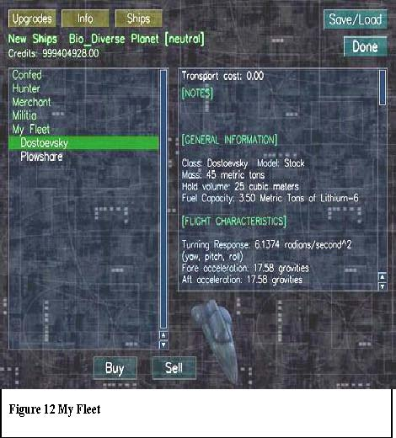
Vega Strike allows the player to own more than one ship at a time, sell unwanted ships and arrange transport of another ship to their current location.
After purchase, a new ship will appear on the Landing Pad, with the old ship placed into storage at that base. The player then continues with the new ship. The player may, however, request that a previous ship be transported to the player's current location – typically when the player has lost their latest ship in battle. The previous ship is delivered to the current location, and the player changes to the delivered ship. The transport cost is displayed when a ship is highlighted. Lastly, if any old ship is unwanted, it may be sold to the open market.
Where a player owns multiple ships, the Ships Screen displays a final category, My Fleet. Clicking on this category brings up a list of all non-active ships owned by the player. When requesting that a ship be transported to the player's current location, highlight the required ship and press the [Buy] button at the bottom of the screen. The ship is transported to the current location, the player changes to it, and is charged the transport cost. To sell unwanted ships, highlight the ship and press the [Sell] button. This disposes of the ship for its current value including upgrades.

7.5 The Bar
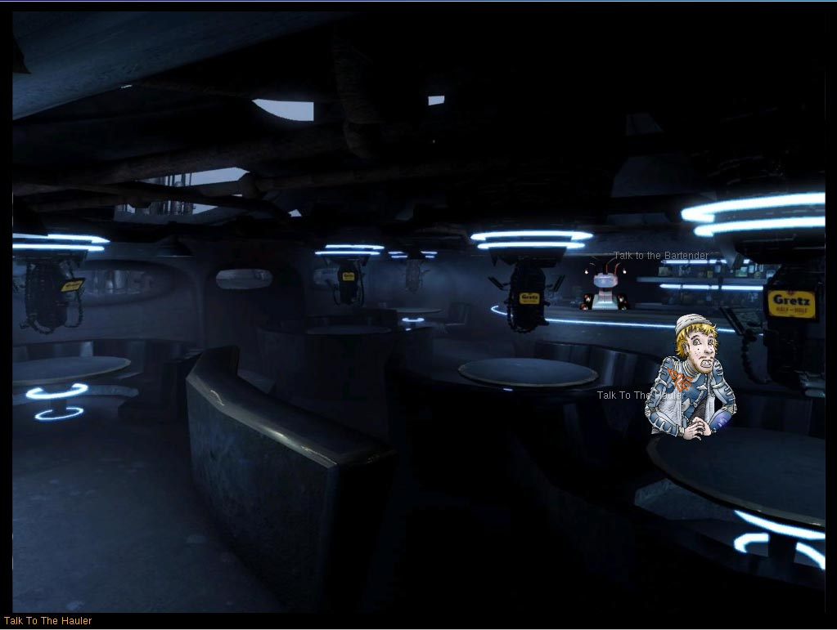
A greater hive of villainy, danger and iniquity you will never find than the local drinking spot. Whether gambling den, tavern, fest hall or respectable dining establishment, most characters in Vega Strike will at one stage or another be found in such a place, having (or avoiding having) a drink and soaking up the ambience. Maybe they're watching to see who else walks through the door... maybe watching you. Are they just acknowledging a fellow denizen of the universe, wanting to have a general conversation with you, hire you for a 'special' mission ... or are they watching for a reason more sinister?

In Vega Strike, the bar, located at most bases in the known universe represents such establishments. While stepping in here to have a drink, you can chat to the bar attendant, catch up on the latest holo-vid news, and look into accepting specialized missions from fixers.

7.5.1 Bar Attendant
Chatting to the local bar attendant allows the player to obtain knowledge of local news, flying tips and occasional bits of valuable knowledge. While most conversation is designed to draw you into staying longer (and drinking more), there are the rare conversations where the bar attendant will let slip some important knowledge about goings on, potential money sources and similar valuable information. Don't discount talking while in your cups!
To chat to the bar attendant, move your pointer over their icon to highlight them and click.

7.5.2 Fixers
Fixers are representatives of the various Vega Strike factions with whom it may be profitable for you to converse with. For more information on fixers, refer to the heading In Game Missions.

7.5.3 News
Want to catch up on the latest occurrences in the Vega Strike universe while you were out clearing the dust off your wings? Switch on the news holo-vid, located to the top right of the Bar. This will take you to the News Screen.

7.6 In Game Menu
This menu function allows the player to save the pilot at a current or new location, load a previously saved pilot, begin a new career or exit Vega Strike completely. To access this menu, you must be docked at a base, which has a [Save/Load] button located to the top right.
Buttons
- Save – Select the save destination in the left box, or click on the box next to [Quit Game] and enter a new save name. Click on the [Save] button to save the pilot to that save name.
- Load – Select the pilot to load from the left box. Click on the [Load] button to import as the current pilot.
- New – Select [New] to begin a new pilot’s career.
- Quit Game -Quit the game and return to your computer system.

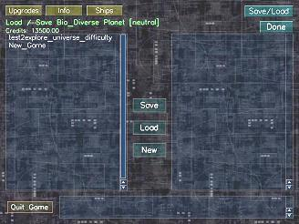

8. IN-FLIGHT
STATUS CHECK
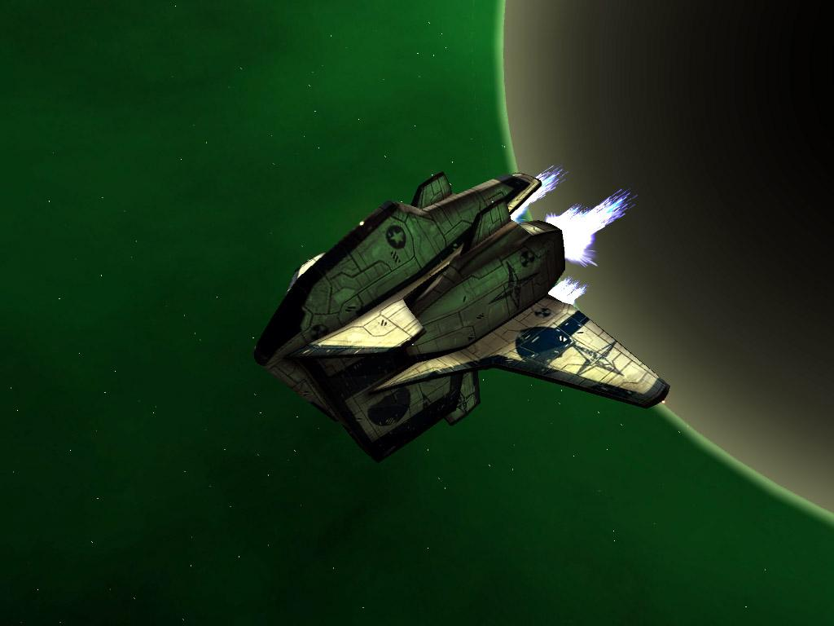

8.1 Basic Flight Training
... In training with Major Dwight Somlen (ret) of the Confederation of Inhabited Worlds military...
(Background, low volume) "What makes you think that these wet behind the ears can learn anything? Do you really think they have the b-" (sounds of interference erupt from your PAD) "to be able to pilot a craft ... what? We're live?"
(Full volume speech) "Greetings, pilots! I've been requested by the control authority to provide some pointers for rookie pilots on how to fly their brand spanking new spacecraft. The good thing is that no matter what craft you're flying -whether a Llama, Goddard, Ox, Mule or whatever -your interaction with the flight controls is the same. Now, many rookies love to jump in, start moving, and figure out the controls as they go. That's fine, and I'll listen to your space debris hitting my shields when I pass your frozen corpse. The smarter pilots learn their controls beforehand, as that half-second difference in flight control manipulation could mean becoming a smear on the side of a station, or a twisted hulk after tangling with an Aevant.
"Now, first things first. How do you move? If you want to change your direction of movement, you need some sort of flight instrument to relay your commands. Let's refer to your instrument documentation -" (low volume mutter, as though to someone beside him) "they DID get that didn't they?" (Full volume) "There are three forms of flight control: joystick; mouse and keyboard. The joystick is pretty self-explanatory. Push the joystick forward, and your ship's nose points 'down'. Pull back and you point up. What? Yes, yes you can invert the controls if you want. Push the joystick from side to side, and your craft will turn on the vertical axis. Some advanced joysticks will even let you roll if you can configure your ship correctly. Now, your mouse does the same job in two ways. First, we have mouse warping. That's where moving your mouse in a direction, moves your ship in that direction. Keep moving your mouse -yep, that's right -and your ship keeps turning. Mouse gliding, on the other hand, means that moving your mouse pointer away from the center moves your ship in the direction of the pointer." (Low mutter) "Me, if I don't have my joystick in my hand, I prefer to glide." (Full voice) "Lastly, you have the keyboard. Both the joystick and mouse imitate the keyboard. Use your [cursor keys] to move up, down, and sideways, [Insert] and [Delete] keys to roll left and right. You can also use the keypad to do the same thing: [KP8, KP2, KP4, KP6] and [KP/, KP*] to roll.
"OK, so now we're spinning around, going nowhere. What we need is thrust -can the laughter you lot up the back! To move anywhere, we need to have velocity. Velocity is determined as relative to the current system’s sun. The following describes the first mode of movement, the Combat Mode. Use the equal [=] or [KP+] and minus [-] or [KP-] keys to alter your velocity respectively. Notice that you can have forward and reverse velocity. To obtain maximum combat velocity, use the backslash [\] key, and the [BACKSPACE] key reduces velocity to zero. Essentially, these commands provide a Requested Velocity Vector, otherwise called a 'set' velocity or speed that your craft will always try to move at. At times, like when turning, your velocity may vary up or down, but your craft will always try to return to this Requested Velocity Vector. The other modes will be discussed in a later lecture.
"That's enough for now. You've probably heard enough of this old f-I know, I know, no swearing. Have a think about what I've just said - it just might mean that I'm NOT hearing your space dust on my shields."

8.2 Advanced Flight Techniques
... Fade in on Major Dwight Somlen (ret) of the Confederation of Inhabited Worlds military...
(Low volume) "... and these nuts want to know more about how to kill themse-" (full volume) "Will someone please tell me when we're on?
"Welcome back pilots! Since I see you're all here, I'd say everyone survived their first piloting experience? Fine, so let’s learn about some more advanced flight techniques.
In the last lecture we learnt about setting your velocity. Now there are a few ways that let us get around the set velocity limit. For those of us lucky enough" (sotto voice) "-rich enough -" (full voice) "to have an Overdrive capability on our craft, you can use the [TAB] key to activate it. Overdrive gives your craft a greater acceleration than your maximum combat drive alone. The downside is that you have to hold the key down to maintain your overdrive activation, and you’re going to burn through fuel faster than an Rlaan can spend credits on antique pop-art. Where you don't have an Overdrive, you can still use the [TAB] key to accelerate to your maximum set velocity, just like the [+] key. In this case, though, releasing the [TAB] will then reduce your velocity back to the ‘set’ original.
What we've talked about so far are the settings you would have when flying around a base, station or planet, or when you're in combat -yes, I've heard all of you boasting. We'll just see who turns up for your reunion, right?
Anyway, to get greater velocity than the Combat Mode, use the [y] key. This key changes mode from combat to Flight Mode. This mode allows you to increase your set velocity by one hundred times. So, why aren't we all jetting about in this mode? Well, there are a few reasons. Since we must still deal with inertia, your craft will drift in your old direction a bit before moving the way you want it. If you wanted to fly around a capship and kept drifting towards it at a high velocity -yes, I can see you all wincing. Secondly, try to imagine combat at such velocities. Your opponent would be out of range by the time you aligned your weapons on him and fired.
Now, all these flight commands deal with inertial movement. Most small craft can pull 10-20 gravities (G's) of acceleration or deceleration, and have a flight system designed to account for inertia. At combat velocities, your craft won't be going fast enough that you really notice the effects of inertia. Larger craft are not designed with large G's in mind, and the effects of inertia mean that changing direction or velocity requires a longer timeframe. Similarly, traveling in flight mode (a higher velocity) will result in the same problem when altering course or attempting to cease all movement - it takes time.
Inertial drift, however, can be a benefit. There's a name for it, the Shelton Slide. It actually works quite well in battle. This maneuver requires you to approach you target at high speed, and a little off center (i.e. not head on). When level with your target, quickly turn to face it while reducing you velocity. Your ship will continue in its prior direction until your computerized flight control can compensate for the change in direction. That brief period allows you to strafe the side of your opponent, often hitting the weaker side or rear armor.

The reason I mention it is that there is also a key, the tilde key [` ] that provides a controlled version of this drift. This command disengages the ship's flight systems from flight control -so your ship will not try and correct velocity or direction. While it doesn't give you six degrees of freedom of movement, you can spin around to face elsewhere while still moving in your original direction and velocity. This is definitely a handy maneuver in battle.
A better way to move around from base to planet to station is to use your autopilot by pressing [a]. If you feel the need to do it sans-assistance, you can manually activate your SPEC drive. You should read the instrument docs that came with your ship for specifics of how the drive operates. Where there are no asteroids or enemy ships blocking your way, you can activate the drive, obtaining high velocities based on any nearby gravity wells - that is, the further you are from a gravity well, the faster you move. A SPEC drive allows you to point your ship in the appropriate direction, and hit the [A] key. Speed increases by a large factor, enabling you to cross inter-planetary distances in only a short period, rather than weeks or months. On approach to your destination you normally re-enter a gravity well, reducing your velocity, and you may hit the key again to deactivate. Note that this function has the effect of attenuating your shields, reducing their combat effectiveness until they regenerate.
The last point I want to raise is Matching Velocity. Now this function also requires knowledge of targeting; so I'll only touch on it briefly. Our calculation of velocity in space is determined relative to a single point in space, usually based on the local sun. At times, you may want to match the velocity of another point, say a ship -usually when docking or in combat. The use of the [HOME] or keypad [KP-7] keys matches velocity with your target. Your set velocity becomes zero relative to your target. Using the [END] or keypad [KP-1] key resets velocity against the local sun.
Well, that's it. You should also note that your instrument documentation has information on other key uses, but they're more specific and outside of the scope of my talk here. I hope at least some of you listened, it may well save your life someday."
(Sigh) “Someone give that fool up the back a kick to wake him up."

8.2.1 Matching Velocity
As the Major states above, a ship's velocity is relative to a point in space and measuring it in relation to the local sun has long since been accepted as standard. When matching against another object, however, the result is that the object you match velocity with essentially becomes the stationary pivot around which your own viewpoint will move. This function also assumes that the new object does not change velocity or direction. Understand too, that your velocity in relation to the local sun may well be quite high -this is the result of inertia and a changed point of view. As such, this function effectively modifies flight control.
To match velocity with a target, you must first lock onto it. You must then use the [HOME] or [KP-7] key to match velocity with your target. Your set velocity then becomes zero relative to that target, i.e. your '0' set velocity becomes the velocity of that ship. Use [END] or [KP-1] key to reset velocity against the local sun.
[BACKSPACE] (Set speed to '0') will assure that your ship is stationary relative to the other star ship (unless it accelerates faster than you and is accelerating).

8.2.2 Docking Procedures
Docking is an integral function of playing Vega Strike. Without knowing how to dock, you can never interact with another base in the universe. There are several steps to be followed in order to dock with a station.
In order to dock at a location, you must first get there. How to target a base or planet, and flying there using SPEC drive or Flight Mode are discussed elsewhere. Once you have arrived, maintain a target lock on your destination.
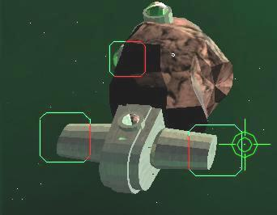
Continue traveling towards your destination. As you close, green and red docking indicators will appear, indicating docking clamps. Green indicators are usable docking clamps. Red indicators indicate that the docking area is either on the far side of a base or ship's superstructure, or damaged; and as such, you cannot dock with that docking clamp.
Approach the green docking clamps under Combat Mode at low speed. When the green indicator fills your screen, you are close enough to dock. To initiate the automated docking sequence, press [d] and your ship will dock. If you are not close enough to the docking clamps, you will receive a communiqué informing you to move closer to the docking clamps. Repeat this step until the sequence begins.
Once docked, your screen will then change from the in-flight HUD, to the Landing Pad interactive screen.
During your approach, we recommend you seek clearance to land at the base or planet. Doing so will communicate your desire to dock ahead to the docking authorities. It is considered polite (maybe it will even improve your reputation), and also has a practical aspect. Seeking clearance will bring up the docking indicators earlier. Pressing [alt-0] (zero) will send a request for clearance to your target. If your target is in-flight, or even in SPEC, and friendly, it will drop out of SPEC and attempt to slow down to allow you to dock when clearance is requested.

Final Note: destinations without a 'type' (Factory, Industrial, Oceanic etc) are uninhabited; while you may still land there, these destinations have no base computers to interact with, and it is usually unnecessary to land there.

8.2.3 In System Transit
There are three potential ways to travel between locations within a system. These are via Combat and Flight Modes, or by using your ship’s SPEC drive. As you could imagine, attempting to travel between locations under the normal modes would require a large amount of time; being nearly useless to a pilot, whether of the merchant or mercenary bent. The degree of compression is restrained by the drive’s distance from any nearby gravity wells, so the nearer a gravity well (sun, planet or even station) the less effective is the drive and the lower the magnitude of movement over normal velocity. You may have heard a metaphor for gravity that states "space is a big soft bed, planets are bowling balls, and smaller balls roll towards the indentations." Well, in SPEC travel, the planets are more like big hills that get steeper the closer you get to them.

The energy costs of interstellar travel are much higher with the SPEC drive as opposed to jumping. It also can take weeks to make some transits in SPEC that take only seconds with a jump drive. As such, SPEC drives are used for interstellar travel only when exploring outside the jump network or when launching a military expedition (as going through the "front door", so to speak, is a good way to get butchered). All space worthy ships are fitted with a SPEC drive for in system travel.
Normally, the autopilot will take care of using SPEC for you. To use SPEC manually, make sure that you are aligned on your target. This means that you are both pointing your ship at your destination AND that your velocity vector is pointing at your target (you are actually traveling in the direction you are pointing). To activate, hit the [A] key. A green SPEC light will appear on your HUD, and your effective velocity will increase. On final approach to your destination, hit the same key again to deactivate the drive and return to your previous flight control. Please also note that your weapon systems and shields are disabled while in SPEC mode. It is not possible to jump, dock or otherwise perform many interesting interactions while in SPEC.

8.2.4 Autopilot
Pressing [a] activates the autopilot. The autopilot will engage both normalspace and FTL drives as necessary to place you near the targetted object. Manual control of the ship will be disabled until either A) you have reached your destination, or B) you cancel the autopilot manually by pressing [a] again.

8.2.5 Interstellar Travel
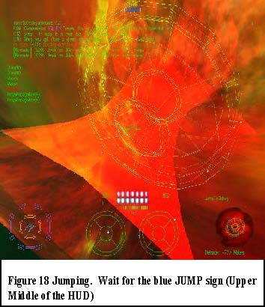
For the history and theory of interstellar travel, jump drives and wormholes, please refer to scientific literature. Here, we discuss the basics and mechanics of how to travel between the stars.
To initiate interstellar travel, a ship requires a jump drive. Jump drives use gravitic technology to access a singularity formed between two previously weakened points in the space-time continuum, joining the two points in interstellar space. These singularities (commonly named wormholes) connect one point in one solar system, permanently to another point in another system. Certain wormholes are rumored to randomly connect two points at random times.
Once a wormhole has been discovered and mapped, it is marked on star charts as a targetable point. An inactive wormhole appears as a wire-frame disk in your HUD. An active, stable wormhole appears as a red whirlpool, while an unstable, random destination wormhole is multi-colored (ED: this feature currently
disabled).
You may target and approach any such wormhole. Where your ship is jump drive equipped, and you are close enough to an active wormhole, a blue JUMP indicator will appear in your upper center HUD. This indicates that you may activate your jump drive [j], open a wormhole and fly through to your destination system. For best results, approach the wormhole directly, not from its side.
Final Note: your starting ship is not equipped with a jump drive at start of play. As such, you are only capable of in system travel. You will need to acquire a jump drive to travel between the stars.

8.3 Take a Look Around You
Vega Strike allows you to look around your ship, and your local space. It does this in two ways: by providing a cockpit view and an outside camera position view. You may move from one view directly to another by pressing the appropriate key.

8.3.1 Cockpit View
Cockpit views are just that: from your pilot's seat, this is what you would see. These views represent looking through the front and side cockpit viewports, and a camera pointing from the rear of the ship.
Name | Key | Description
View Forward | [1] | This view is what appears initially in flight and is otherwise known as the cockpit view. This view contains all the necessary information and displays to fly. While in view forward, pressing [1] will change from the cockpit view (with cockpit struts) to the Heads Up Display. The HUD provides the same information as the forward view but removes the cockpit surround. Press the key once more to return to cockpit view.
View Left | [2] | This view is looking through the cockpit plasglass over your left shoulder.
View Right | [3] | This view is looking through the cockpit plasglass over your right shoulder.
View Reverse | [4] | As a pilot cannot look back through the ship, this view represents a camera mounted and looking to the rear of the ship.

8.3.2 Camera View
A camera view is best described as a single viewpoint or eye located in one position in space. The Panning Camera's ([6] and [8]) position is moveable. While in these views, use these keys [q,z,s,f] to move the camera position in the appropriate direction.
Chasecam | [5] | This view seats a camera behind and above your ship's engines, looking forward. This position is static no matter the ship's movements. Best imagined as having a second ship tailing your current ship, with you in that second cockpit. This view allows you to examine all markings and detail on your ship.
Panning Camera | [6] | This view positions a camera at a single point in space, facing your ship. You may rotate the camera about your ship using the panning keys.
Target Camera | [7] | This view places the camera at a location looking past your ship towards your current target.
Target Panning Camera | [8] | This view positions a camera at a single point in space, facing your target. You may rotate the camera about your target using the panning keys.
Zoom View In | [9] | While in one of the camera views, this function will move the viewpoint towards the object viewed.
Zoom View Out | [0] | While in one of the camera views, this function will move the viewpoint away from the object viewed.

8.4 The Heads-Up Display
The Cockpit View and Heads-Up Display (HUD) are the primary interfaces with Vega Strike while in flight. The individual areas of the Heads-Up Display are discussed below in clockwise order from the top left.

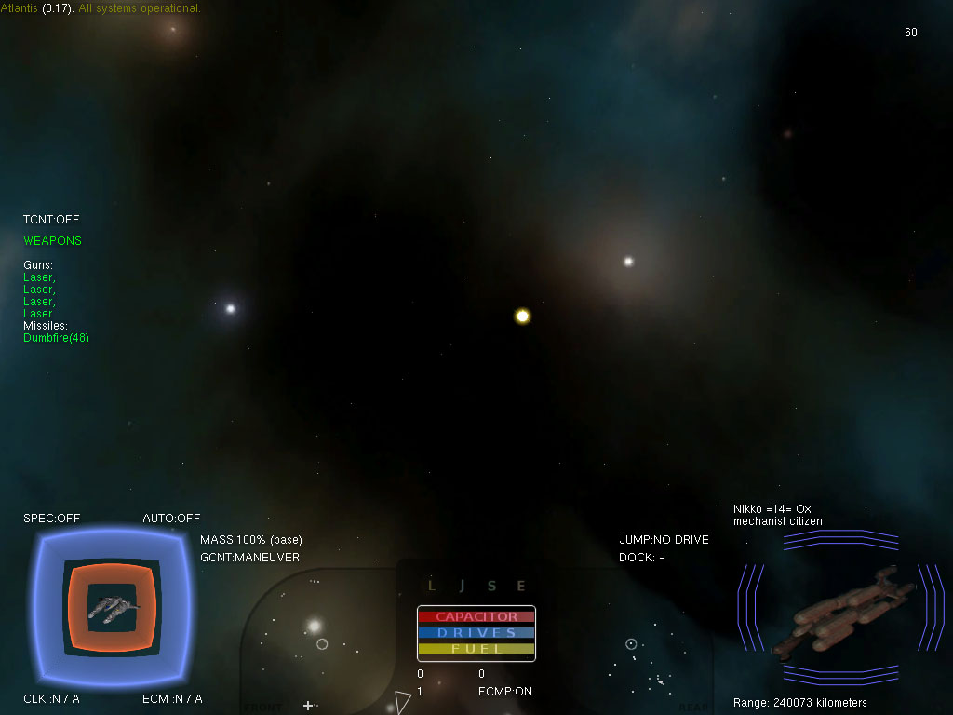
HUD
Communications
Located at the top left of the HUD.
In the communications section, the first line indicates your current targeted destination, beside which is a counter denoting the time that has passed since launching from dock.
As conversations appear, read them from left to right. The first indicator is the originating source of the communiqué, whether a flightgroup, station or base. Next is the time stamp, being the time showing on the counter when the communiqué originated, followed by the actual lines of the conversation. Conversations are color coded reflecting your current reputation with the object communicating.

Indicator Lights
Located at the Center Bottom are four indicator lights:
- The SPEC light indicates whether the SPEC drive is currently activated.
- The JUMP light must be on to engage the interstellar drive. If it is off, you must manually fly closer to a targeted wormhole. Once you have a distance of zero, this light will normally activate, unless there is something else preventing activation.
- The ECM light is a redundant indicator of ECM status (see ECM status display)
- The Lock light activates when a hostile craft has achieved a missile lock on your ship.

Other indicator lights
- The OVERLOAD light, located at Center Top, when active, indicates that your reactor is going critical, and you ship is about to explode.

Status displays
- AUTO --> AUTOpilot activity status
- CLK --> CLoaKing device status
- DOCK --> DOCKing readiness
- ECM --> Electronic CounterMeasures
- FCMP --> Flight CoMPuter
- GCNT --> Governor CoNTrol (Maneuver/Travel)
- JUMP --> JUMP drive status
- MASS --> total MASS of vessel + upgrades + cargo as % of base mass of vessel
- SPEC --> SPEC drive status
- TCNT --> Turret CoNTrol
Frames per Second
(ED: this is an internal game control/developer testing assist to measure computer performance during gameplay.)

Missions
Where you have accepted missions, those mission objectives will appear to the Center Right. Missions may be viewed by scrolling using the [PGDN] & [PGUP] keys.
Upon completion (or failure) of a mission objective, you will receive a communiqué (see communications above) informing you of the result. The objective recorded under missions will change color as well.
Right Video Display Unit (VDU)
This Video Display Unit is activated by use of the key [v]. This key will also cycle through the various selections. These selections are:
- Object View: displays a 3D representation of the targeted object. If the object is a ship, it also displays a red coloration as the target takes damage, and shield strength with bars that reduce as shields collapse.
- Navigation: displays printed information on a targeted object, including its location with respect to your position.
- Communications: displays a list of potential communiqué you may make to your targeted object. A low number is friendlier than a higher number.
- Target Manifest: displays the cargo manifest of the targeted object.
- Target Camera: displays a real-time picture of your targeted object from the rear.
- Target Panning Camera: displays a real-time picture of your targeted object using a panning camera.

To scroll up or down a selected screen, use [PGUP] or [PGDN].

Ship Displays
Located to the Bottom Center are the ship displays. These include:
- Scanners: These two circles represent the forward detection array (left) and the rear detection array (right). All detectable objects (ships, bases etc) are represented by dots on this display. If the object is ahead of you, the corresponding dot will appear in the forward display, to the rear in the rear display. Your currently targeted object will appear as a cross. On obtaining Detection Array upgrades, these dots may be color coded to reflect your reputation with the object.
- Current Velocity: located above the left detection display is the Current Speed Indicator. This indicates the forward velocity of your ship, taking into account overdrive use and changes in direction.
- Set Velocity: located above the right detection display is the Set Speed Indicator. This indicates the forward velocity your ship travels without changes in direction or after burn.
- SPEC Velocity: located below the Current Velocity indicator, this displays the multiplication factor the SPEC drive gives to your current speed.
- Weapon Energy: the red bar located above the detection displays is your energy weapon capacity. Firing energy weapons drains this capacity, but is restored after ceasing fire, provided the reactor has sufficient additional capacity.
- Jump Energy: the blue bar indicates system drive capacity. Use of both in system and interstellar drives drains this energy. If the energy recorded is insufficient, you cannot activate either drive.
- Fuel: everything consumes fuel. The reactor consumes fuel to generate energy for the capacitor banks, the engines use fuel to maneuver the ship, and the overdrive uses even more fuel to squeeze out a little extra acceleration. To avoid a ship being stranded in space, secondary functions will become disabled once discretionary fuel supplies are exhausted. Once used, your ship must be refueled at a base.
- Enemy Lock: This light indicates that an opponent has you target locked.

Shields Display
Located to the bottom left, this display is a 3D representation of your ship. It displays the strength of both your shields and armor. Shield strength can be regenerated provided your reactor has spare capacitance, but armor is finite and must be replenished at a base. Should your ship take enough damage to reduce shields and destroy armor, your internal ship components will take damage, reflected in an increase in red color in the representation. Too much damage will result in ship destruction.
Left Video Display Unit (VDU)
This Video Display Unit is activated by use of the key [m]. This key will also cycle through the various selections. These selections are:
- Weapon Display: displays your ships currently selected weapons. If your weapons have a finite supply of ammunition (solid state and missile/torpedoes), remaining ammunition is also indicated. You may toggle selected weapons using the key [g]. You may toggle selected missiles and torpedoes using the key [w].
- Ship Display: displays a 3D representation of your ship, your flightgroup name, ship hull strength, and whether you have special equipment active or inactive.
- Cargo Manifest: displays your current cargo, any mission cargo, and upgrades that are stored in your cargo bay. Note that the topmost shown cargo may be ejected.
- To scroll up or down a selected screen, use [PGUP] or [PGDN]

Targeting Reticule
In the center of the HUD is a crosshair. This indicates where your weapons are zeroed (i.e. focused to cross and cause the most damage). During combat, you will usually attempt to have your opponent appear in this crosshair when firing.

Where you have a targeted object in your front viewscreen, that object will appear with an open square bracket surrounding it. Where you lock onto your target, the square will be solid. If you have missile lock on your target, a diamond will appear around the square. Lastly, where your ship is fitted with ITTS, a small diamond will appear in front of your targeted object.

Directional Pointer
Where you have locked onto a target, but the target is not currently in your forward view (e.g. target is to the side or behind you), a directional pointer will appear on the edge of the HUD. This pointer provides an indication of the direction and location of your current target.

8.5 Map Screen
Just as in ancient times, the ability to navigate required more than just seeing what was around you. Navigation also required accurate maps depicting locations over the horizon and dangers hidden away out of view. In spatial navigation, the importance of maps is magnified greatly, as sight alone is all too limited (one cannot usually see an orbital station from a planet's surface, let alone another planet).
Further still, while it is possible to navigate around a solar system using targeting data only, traveling from system to system in the Vega Strike universe would be aimless wandering without adequate maps to provide navigational data. Finding a single system would be near impossible, without reference to a map of the stars.
The Map Screen may only be activated while in-flight. The player should note that activation of the map screen does NOT pause the game. Flight controls still operate, opponents will continue to attack, and the game otherwise continues while viewing the Map Screen.
The Map Screen is activated/deactivated by pressing [M]. It appears superimposed over the cockpit view or HUD.
The Map Screen consists of a viewscreen located on the left, and a series of activation buttons to the right. Clicking on the buttons toggles between the two modes described below, and activates functions for each mode.
When activated, this function defaults to the Statistical Mode. This is the screen that initially appeared when starting Vega Strike. This screen provides the basic information required to play the game. It is a condensed form of the more common functions mentioned in this manual. Note that on re-activating the Map Screen, whichever mode was last viewed is the one that appears.

Statistical Mode
The Map Screen provides two different modes. The Statistical Mode is the default that first appears when the Map Screen is activated. This mode provides information on all of the factions that may be encountered in Vega Strike. Each faction listing has a reputation rating ranging from positive (green, allied) down to negative numbers (red, enemies), with several other ratings in between. The second number recorded is the number of that faction's ships destroyed by the player. At the bottom of the list is a record of Total Kills made. This screen also displays help information, providing a basic guide on how to play Vega Strike.

This mode will also provide information on your current ship's physical statistics. It records the current value ratings for your ship's armor, shields, weapons, maneuverability statistics, scanner detection capability, propulsion systems and so forth.
- Navigation = Selects navigation function.
- Information = Selects information function.
- Up = Toggles to the Ship's Statistics screen.
- Down = Toggles to the Faction Relations screen.
- Button 5 = (ED: this button is currently inactive)
- Button 6 = (ED: this button is currently inactive)
- Button 7 = (ED: this button is currently inactive)

This information may also be accessed on a base via the Player Information Screen.

Map Mode
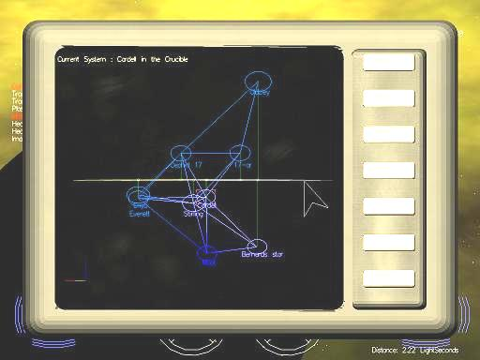
The Map Screen provides two different modes. In Map mode, the player may examine a three-dimensional map of their currently located solar system. This map will provide information and location of all planetary bodies, artificial satellites, and bases, as well as known spacecraft, color coded by faction.
It can also display a three-dimensional map of all known solar systems. It displays systems with names and color coding to represent the faction holding system, and system links showing which systems have wormhole singularities for travel between linked systems.
- Navigation = Selects navigation function.
- Information = Selects information function.
- Button 3 = (ED: currently no function)
- Up = Toggles the Sector Map.
- Down = Toggles the System Map.
- Axis = Rotates the viewed map around its axis.
- 2D/Ortho/3D = Select varying viewpoint representations.
- Select Object = Click on object with [LMB] to select object or system.
- Map Rotate = Click [LMB] and hold to rotate through x,y,z axes.
- Zoom = Click and drag Middle Mouse Button = Scroll Wheel

8.6 Targeting
One of the most useful shipboard abilities in Vega Strike is Targeting. While most pilots consider targeting as only useful in combat, in truth it is required to perform nearly all in-flight functions.
The ability to navigate, both in and out-system, requires a pilot to lock onto a navigation point (base, planet, sun, wormhole, ship etc). Communication requires you to lock onto a target, before selecting which communiqué you will give. Wingmen require you to target them before giving orders.
As such, learning how to target is an important skill, possibly making the difference between targeting and shooting your opponent before he does you, or, making an escape with your cargo intact and not becoming space debris.
Various keys allow the pilot to target different points of interest within a system. You can cycle through all available targets within a system. This is usually when you want to see what's out there. Unfortunately, cycling through all targets is a long process. As such, other targeting keys are more specific. You can cycle through all significant and/or neutral targets such as bases, planets and points of interest. You can narrow this further and only cycle through non-natural targets such as stations and ships. The most important for battle is the ability to cycle through targets hostile to you. You can also cycle through these targets in reverse.
When targeted on large ships or stations, you can also cycle through their sub-units. Lastly, you can point your ship at an object and target it that way.
Once you have a target marked, you can lock your target indicator to that target. Wherever you are facing, or your target is, you can find them without having to hunt through all other targets in the system. This locking capability also allows any missiles or torpedoes carried to also lock onto your target.

Name | Key | Description
All Targets | [t] | Cycles through all targets in the current system within radar range, as well as all navigational targets & Capital vessels.
Navigational Targets | [n] | Cycles through all navigational targets in the current system.
Non-natural Targets | [u] | Cycles through all Non-planetary/non-natural units (such as capships and fighters) within radar range.
Hostile Targets | [h] | Cycles through all hostile (to you) targets within radar range.
Subunit Select | [b] | Cycles through the sub-units of the ship you have currently selected.
Lock On Target | [l] | By pressing this key you can 'lock' your selection on the currently selected target.
Front Target | [p] | Pressing this key will pick the target closest to your crosshair. Tends to be used to target planets in front of you.

Please note the [t,n,u and h] targeting features also work in reverse by using [SHIFT+key].

8.7 Communication
Pilots are not just traveling through a void in space. They must interact with a variety of ships, bases, stations and planets. While they can certainly interact -all weapons blazing -such a career is not likely to last long.
The ability to communicate with others in space opens up many options. Being able to say hello, engage in psychological battle with an opponent by using taunts, appeasing factions to repair reputations (by begging for mercy), or to give a blood-curdling scream as your ship disintegrates around you...
The reactions of various factions may be influenced depending on your comms. If you choose particularly menacing taunts, your target may attack you instead of its current target. Likewise you can restore relationships with hostile people with friendly comms. Specific comms messages will be derived from your reputation with your target, as well as any previous conversations you have already had with them.
You can request permission to dock at bases. Doing this before actually docking may improve your reputation with that faction, and will trigger the docking clamps earlier on your approach.
A word from the wise: when being scanned by militia, they will request that you not deviate from current course and speed. Should you do so, they will assume you are carrying contraband and act accordingly.

To communicate with others, you first need to target them. Once targeted, you may then choose what dialogue you will have. To see the types of dialogue, open your VDU to comms mode by cycling with the
[v] key. This brings up a list of numbers corresponding to actual dialogue. Pressing the appropriate numbered key [F1] to [F8] will transmit that message to your target. Lower numbered comms are more friendly than higher numbers ([F1] being friendliest). Your message and any replies will appear in the communication VDU at the top of the HUD. You may also use the numbered keys as hotkeys for immediate sending, but you will not see your dialogue beforehand.
To request docking permission, Press the key [alt-0].

8.8 Wingmen
As a pilot, you will find that many a time, attempting a mission or flying a cargo through dangerous space is impossible by yourself. When this situation occurs, having another pilot on your wing (or several) may be enough to shift the odds.
Wingmen give you the ability to have multiple ships engaged on a mission, not just your own. As leader of your own personal flightgroup, you can order your wingmen to perform most of the actions you are capable of in your own ship. More specifically, you can order them to attack the target you are currently locked onto, come rescue you if you're taking fire (brilliant for the larger merchant vessels), and form them up on your wing.

8.8.1 Commanding Wingmen
Following is a list of available commands:
Press [alt-F] to have them form on your wing. This command places your wingmen in formation with you. They will fly defensively, but attempt to remain in their position. This command is commonly used to have wingmen follow you through a wormhole.
Press [alt-B] to release them. This command releases them from the above order. Essentially, they are weapons and flight free.
Press [alt-H] to help you out. As noted above, where your ship is under fire, using this command will cause your wingmen to attack whoever it is firing on you. Hopefully they will destroy your opponent, but the key is to draw your opponent's fire away from you.
Press [alt-D] to have them attack your target. Where you specifically want your wingmen to attack a target, whether for defensive purposes, or a mission objective, use this command.
Be warned however, that wingmen tend to be fickle and may not always obey your commands. They will inform you whether they will or not.
Just a final word. When flying escort missions, your own escorts will follow wherever you lead, and escort you to your destination. To travel through a wormhole, stop in the wormhole, wait until they get near, and then press [j]. They will follow you through the wormhole and appear on the other side. Continue to the next destination. Getting escorts right is essential to completing many of the plot missions.

8.8.2 Hiring Wingmen
To hire wingmen, you need to have access to a Mission Computer. From the mission screen, highlight the
wingmen category. You will then see a list of available wingmen, providing a description of the pilot, flying ability, statistics on what type of ship they pilot, and a price for hire.
Wingmen are aware that they are typically hired for dangerous jobs. As such, they demand payment up front before accepting your commission. Clicking [Accept] will hire the highlighted wingman and reduces your total credits by the hire cost. Your new wingman will fly on your wing until you next dock.
See also Mission Types.

8.8.3 Cargo Wingmen
Larger cargo transports can carry fighters as cargo (a miniature carrier). Fighter cargo can be jettisoned and commanded just as hired wingmen. When battle ceases, your ship can then tractor these cargo fighters back in.
You will need a Tractor Beam to fully use this feature. Cycle your left VDU [m] to your cargo list, and [PGUP] or [PGDN] to position the wingman in top position. Press [Z] to eject your escort.
A further ability you have with cargo wingmen, is the use of the Control Switch [[ ] key. First, target a specific wingman, then press the Control Switch key. Your own control has now shifted from your primary ship, to control over your wingman's ship. You can now pilot your fighter wingman in direct battle against your opponents.
After battle has ceased, return control using the same key back to your primary ship. From there, activate and use your Tractor Beam on your fighters, hauling them back into your cargo bay.
Then, just continue on your merry way!

9. COMBAT
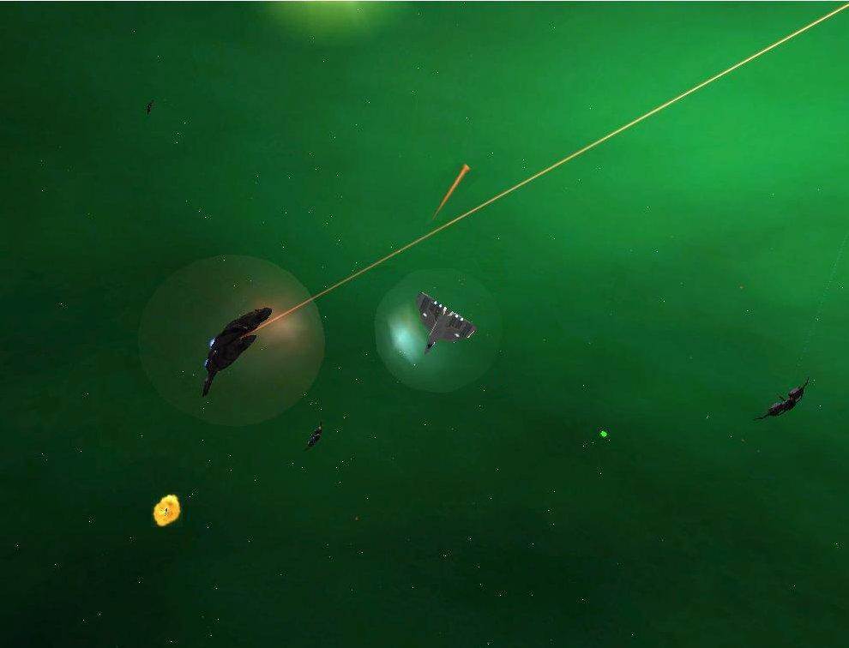

9.1 Engaging in Combat with an Opponent
The Vega Strike universe is, by its very nature, a dangerous place. You are confronted with the danger of navigating into a star; your ship's drive malfunctioning, turning it into a floating coffin; the hull being holed, losing atmosphere; even a lack of supplies to last a journey. The greatest danger by far, though, lies with other sentient beings.
Vega Strike is set against a backdrop of interstellar war between three dominant (and several client) races. A pilot could easily be caught up in this war, and must defend against all types of assailants. Further still, you must also deal with dangers from your own kind. Pirates, merchants, even the militia may be after you, your ship or your cargo.
Survival requires more than heavy shields, high afterburner velocity or a nearby wormhole. Combat skills - the ability to bring down your opponent and halt their attacks on you -are highly valued in Vega Strike. So, do you have what it takes?
Combat involves several functions already covered in other sections of the manual. These include Flight Techniques, Targeting, and Communication to name only a few. What we are concerned with here are the absolute basics required to engage in successful combat.
Usually, the first warning that you are engaged in combat will be either a communiqué from your opponent, seeing them fire, or worst of all, hearing their weapon's impact and seeing your shield levels falling. A flashing light near your power displays will also provide an indication of someone firing upon you.
The first you need to do is locate, target and lock onto your opponent. It is recommended that you remain focused on that one opponent. This ensures that they do not have time to recharge their shields, while yours take a battering.
In the center of your flight screen (the HUD), is your targeting bracket. Your initial vessel (a Llama class ship) comes equipped with a forward mounted weapon that fires a burst of energy centered on this bracket. When engaging in battle, you will need to keep your opponent located within this bracket, giving a better chance of hitting your opponent with your weapon.
Your right Video Display Unit (VDU) shows a three dimensional (3D) representation of your opponent. As you hit your opponent, you will note that their shields reduce to nil. At this stage, any further hits begin damaging armor, followed by internal components. As damage accumulates, the ship representation will become a deeper red. Once enough damage has accumulated, you opponent's ship will then explode.
At this stage, use your targeting keys to focus on your next opponent. If all opponents are destroyed or have fled, you have succeeded - Congratulations!

9.1.1 Guns
Available guns come in several different formats. They include energy pulse weapons, energy beam and solid state. Solid state weapons have a finite amount of ammunition, recorded in a counter next to the weapon description. All other energy weapons are powered by the spare capacity of the ship's reactor. This is represented by the red energy bar located in the HUD. For a full description of available weapons, please consult the online database http://vegastrike.sourceforge.net/wiki/Database.
Firing a weapon will either reduce the amount of finite ammunition, or reduce the surplus energy available. Depletion of ammunition or energy will cause the weapon to cease firing. Where the ship has spare capacity, and energy weapons are not firing, the energy bar will slowly increase back to full. Solid state ammunition may only be replenished at a Weapons Room.
Ships with multiple gun mounts may have several different types of guns available. These are displayed in the left VDU weapons display. The player may cycle between the various available guns, selecting the required gun for firing. The final selection will highlight all available weapons. This selection is called full guns and enables all available guns to fire.
To cycle through available guns, use the key [g]. To fire a selected gun, use the [SPACE] bar (joystick trigger (button [0]) or left mouse button).

9.1.2 Missiles and Torpedoes
Vega Strike has a large selection of missiles and torpedoes available. For an explanation of the effect of each type of weapon, please consult the online database http://vegastrike.sourceforge.net/wiki/Database. While their effects vary, their operation in combat is the same.
These weapons consist of primarily a solid tube with a propulsion system, guidance system (most models) and a warhead of some type. They are mounted in dedicated weapon racks on your ship, and launched at your opponent. Acting as a miniature ship, your missile or torpedo will approach its target, and when within range will activate its warhead (causing explosive damage or various other effects).
In order to use a missile or torpedo you must first target and lock onto your opponent. This activates the locking mechanism (if any) of your weapon. You will hear a lock tone, and see a diamond appear around your opponent once the weapon has its own lock. To fire, press the [ENTER] key or [KEYPAD ENTER]. As with guns, you may have a selection of different missiles and torpedoes. Where this is the case, you may cycle through them using the [w] key.

9.1.3 Inertial Target Tracking System (ITTS)
Certain upgradeable scanner systems have the ability to track and record your opponent's speed and trajectory. Using this data, plus your ship's speed, trajectory and weapon velocity, the ITTS calculates a lead point located in front of your opponent's ship. This lead point is the aiming location that gives the greatest chance of hitting your opponent. Your lead point appears as a small diamond located at a varying distance in front of the nose of your opponent's ship.

9.1.4 Electronic Counter Measures (ECM)
Electronic Counter Measures are designed to foil missile and torpedo attacks on the craft to which they are installed. Activation of ECM lets loose a barrage of electromagnetic noise, focused false radar/lidar images, Infrared beams, and altered signatures intended to confuse missile targeting systems into misjudging the size, location, and direction of the ECM user. While not necessarily 100% successful, such measures do reduce the number of successful attacks with such weapons. ECM foils an opponent’s attempts to reduce shields and armor on your ship, let alone suffering the effects of more sophisticated attack methods.
ECM can be activated and de-activated using the [e] key. ECM is also self-activating on detection of an approaching missile or torpedo. The use of ECM is draining on your ship's reactor; therefore you will note that weapon and jump energy may reduce while ECM is activated. Provided your ship's reactor has spare capacity, de-activating your ECM will restore those energy levels.

9.1.5 Cloaking Device
A cloaking device has the effect of rendering your ship invisible to the naked eye and electronic detection equipment. It does so by using a gravity lens to 'bend' emitted radiation (visible light and detection signals) around your ship. From a detection point of view, the ship is ‘invisible’ to detection equipment; and to the naked eye all that is visible is the background behind the cloaked ship, enclosed by a faint ship’s outline. Unfortunately, use of a cloaking device requires both a substantial supply of power, and deactivation of your shields to minimize emanations.
Key [c] activates and de-activates a cloaking device once installed.

9.1.6 Tractor Beam
A tractor beam utilizes gravitic technology to attach an ionized energy beam to a target. Once activated, the beam will increase gravitic power, thereby drawing the targeted object closer to the tractoring ship. Once close enough, and the object is sufficiently small, it will be stored away in the ship's cargo bay.
Where your ship is not equipped with a tractor beam, but is capable of being equipped with one, go to the Weapons Room and acquire it. If you ship isn't capable of equipping a tractor beam you may want to buy "tractor capability" beforehand. (ED: does anybody know what requirements your ship must meet to do this?)
A tractor beam is commonly used to capture loose cargo pods and miscellaneous debris -typically being employed after a battle. A favorite with pirates, it is also used by merchant fleets to transfer cargo between ships and on mining ships extracting raw materials from asteroid fields.
An interesting usage of the tractor beam is where a sufficiently large ship (such as the Ox) employs a tractor beam to capture whole ships (typically fighter craft). Once rendered inoperative, the craft are tractored into the cargo bay and transported for sale at the next point of call.
A derivation of the above, is the use of pre-purchased cargo ships as wingmen. Please refer to Cargo Wingmen for further information.

A tractor beam is installed to a gun mount in the same manner as any other weapon. To use a tractor beam, cycle through your guns using [g] to select the tractor beam alone. Target and lock onto your object of interest, use [HOME] to match speed, [TAB] to after burn close to the object and fire the tractor beam using [SPACE BAR] to capture the object.

9.1.7 Turrets
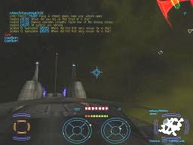
While most ships have forward firing weaponry mounted, many ships, including large fighters, cargo haulers and capital ships, also mount turrets located in various positions around the hull. As these ships are generally unable to engage in a dogfight requiring high maneuverability, these turrets form the main line of offense and defense.
While turrets vary in size and firepower, they all operate in a similar manner:
Press [] ] to select and enter a turret. Repeatedly pressing this key will return you to your cockpit, then cycle between any additional turrets and the cockpit.
Turrets must be activated to use their own Artificial Intelligence. To toggle the AI of your turret, you must press [o]. This will activate the turret, which will then proceed to attack your current target. Pressing [o] again will deactivate the turret.
Turrets can also be told to attack a target. While in forward [F1] view, select their target and press [P]. Once they attack this selected target, you may change targets, while your turrets continue on the original.

9.2 Death

9.2.1 Ejection
When your craft is disintegrating around you, you must make a split second decision: do I die, or eject from the remains to fight again another day.
Ejecting from your ship places you in an ejection pod. This pod is fully enclosed and self contained, with limited shields, weapons and its own propulsion. Ejected pilots are then able to make their way back to a friendly base, as though they were piloting a normal craft.
While the pilot is now missing both a ship and any cargo carried, all funds are retained. Thus, a new ship can be outfitted, or where the pilot maintains a fleet of ships, one can be called under My Fleet.
Activation of the ejection sequence is via the key [Alt-E]. You may then maneuver the ejection pod as if it were a normal ship.

9.2.2 Self-Destruct
Frequently used to rid a player of a pilot character to which they hold no further interest, a player may self-
destruct the current game. Doing so causes the destruction of the current ship, and the death of the pilot.
The game will restart as though a new game had been selected.
Activation of the self-destruct is via the key [!].

9.2.3 Respawning
It is the nature of the Vega Strike universe that any travel a pilot makes, is made at their own risk. Sadly, in spite of the skills of the pilot, the ship type, and the upgrades on board, it may well be that your character will die - nobly in battle, or ignobly as a smear against the side of a station or capship.
Death in Vega Strike is not finite. While you may, if you wish, start right from the beginning in a new game, with a fresh Llama, no jump drive and 13500 credits, most players use the option to respawn.
Respawning returns the pilot to the last saved game. You lose any missions or mission cargo you were carrying, but at least you have your health and your ship.
To respawn a character, press the semi-colon key [;].

9.3 Miscellaneous Gameplay Functions

9.3.1 Quitting
Quitting and exiting the game may be accomplished in two ways. While in flight, press [ESC]. This brings up the quit function in the background operation of Vega Strike. Pressing
[q] will then quit the game. Otherwise, press [ESC] again to return to normal flight. To quit from a base, enter a base computer screen, select [Save/Load], then [Quit Game]. Please refer to In Game Menu.

9.3.2 Pause
To pause during play, select either the [PAUSE] key or use pipe [| ]. Press again to resume play.
9.3.3 Music
Both music and sound are an integral feature of Vega Strike, providing the right mood and atmosphere; whether on a base, in the middle of space or a major battle. While initial settings for volume are determined at configuration, these settings can be adjusted in game. The player may also skip any music track being currently played.
Refer to the controls below:
Name | Key | Description
Skip Music Track | [S] | Skip Music Track
Sound Volume Up | [F9] | Sound Volume Up
Sound Volume Down | [F10] | Sound Volume Down
Music Volume Up | [F11] | Music Volume Up
Music Volume Down | [F12] | Music Volume Down

10. Resources

10.1 Vega Strike Homepage
Find the latest news, files, forums and all other Vega Strike related information at this website:
http://vegastrike.sourceforge.net/

10.2 Vega Strike Forums
Follow the latest conversations amongst the Vega Strike community here:
http://vegastrike.sourceforge.net/forums/

10.3 Vega Strike Files
Find the latest stable releases for all platforms here:
http://vegastrike.sourceforge.net/getfiles/

10.4 Vega Strike Project Page
Find both the current and historical source code for both the stable releases and unstable developer’s copies:
http://sourceforge.net/projects/vegastrike/

10.5 Online Player’s Guide
An online copy of the information contained in this guide plus the latest changes are available at the website:
http://vegastrike.sourceforge.net/wiki/Manual

11. Appendix 1: Tutorials
Where ever you see letters in bold and bracketed (for example: [LMB]), please press that key. Note that [LMB] and [RMB] are left and right mouse buttons respectively.

11.1 Tutorial 1: First Arrival
It is suggested that the player read Chapter 7 before continuing.

After loading Vega Strike, the first screen to appear in front of you is the Concourse for the Oceanic planet Atlantis. Notice in the center view is your ship, currently located on the Landing Pad. Located around your ship are various access points to the remainder of the base. Use your mouse and scroll around your screen. At certain locations, you will notice writing appear at the base of the screen. This writing informs you of an access point, and what location on the base it will lead you to. Alternatively, click the [RMB], which takes you immediately to each point in sequence.
The Bar
Locate ‘the Bar’ since we’re after a bit of R&R. When the access point is highlighted and the name appears click the [LMB]. This activates the location, and ‘The Bar’ will appear as a new interactive screen. Here at the bar, you can always chat to the bartender to get the latest information, game play hints and gossip. Highlight the bartender, and click the [LMB]. His conversation will appear at the top of screen. Repeated [LMB] clicking will trigger various conversations.
Above the bar is a holo-vid screen. Highlight and click the [LMB]. This takes you to the News Screen. Since we have only just started the game, there has been no news. Later, accessing this screen will let you see the latest news happening all around the known universe. [LMB] [Done] button on the screen to exit and return to the bar.
Occasionally, fixers will appear in the foreground of the screen, usually seated at a table of some sort. Fixers make available various missions, equipment or knowledge for playing Vega Strike. If there is a fixer here, highlight the fixer and click the [LMB]. The fixer will discuss whatever it is that concerns them, and should they offer you a choice, a decision menu will appear. For now, select [No] on the screen with the [LMB].
Locate the bar exit point, and [LMB]. We arrive back at the Concourse.

Mission Computer
Well, I’ve had a drink, so what’s a pilot do for fun around here?
From the Concourse, locate and enter the Mission Computer using the same process used to enter the Bar. Look familiar? Here we are, back at the News Screen, but there is a difference. You can access the News Screen from either the bar or via the Mission Computer. You will notice, however, the top of the screen shows two buttons, [News] and [Missions]. The [News] button accesses the News Screen in the Mission Computer. The [Missions] button accesses the Mission Screen. [LMB] [Missions] button.
We are now in the Missions Screen. From here, you can review what basic missions are available. While fixers offer more dangerous, more interesting (and more lucrative) missions, they are often few and far between. The missions here are more standard in nature (but not necessarily less dangerous!). [LMB] on one of the green categories. The category expands to show the available missions of that type. Highlight one and click the [LMB]. Notice that the details of the mission appear in the right hand screen. If you wanted to accept the mission, you would [LMB] [Accept] at the bottom of the screen. We’re not quite ready for missions, however, so we’ll leave the Mission Computer and return to the Concourse using the [Done] button.

Cargo Computer
If I want to get anywhere in this universe, it’s going to take money, and lots of it!
The simplest way to make money is to trade cargo. Buy where it’s low priced, and sell high. To do this, you need to access the Cargo Computer. Notice at the top of the screen, the type of base you are on (Atlantis, it’s an Oceanic planet). Underneath, you may note that you have 13,500 credits to spend, and 2000 cargo spaces to fill. Your aim here is to obtain as much low priced cargo as you can afford and that your cargo space can take. The types of cargoes available are classified by category with many having subcategories.
An Oceanic planet is typically a rural type of planet, big on producing natural products such as food, timber and other renewable resources. As such, select the Natural Products category. You will see a drop down of subcategories: Food, Liquor, Natural Resources and/or Plants. Don’t be worried if one or more don’t appear, not all places produce the same goods all of the time.
Lets look at what Food is produced at Atlantis. The Food subcategory opens out to show various types of cargo, colored white. This means that we have both the room in our cargo bay to fit the cargo, and the credits to buy them. If we didn’t, they would be red in color, and we wouldn’t be able to buy them. Highlight the first cargo under Food. Notice that three buttons appear in the center of the screen, [Buy], [Buy 10] and [Buy 1]. These buttons let you buy (respectively) all the cargo available, ten (10) of the cargo, or one (1) of the cargo. Press [Buy]. Notice how the cargo disappears from the left, and appears in the right screen? Similarly, your credits and cargo space have reduced. You have now bought the cargo. If you wanted to sell the cargo, you would highlight it in the right screen, and click the [Sell] button that appears.

We want cargo to trade, though, so stay in the left screen. Repeat the above sequence to purchase as much cargo under Food as you can. Most likely, you will have credits and room in the cargo bay to spare. If so, move on to the next subcategory and purchase what you can from there.
When you cannot buy more Natural Products (due to lack of credits, lack of cargo room or no more cargo available), click on the [Save/Load] button. This takes you to the In Game Menu. From here you can exit the game, save your game or reload a previous save. Highlight your pilot’s name, [LMB] [Save] and confirm to save your game. If anything happens later, we can always reload.
[LMB] [Done], and exit back to the Concourse.

Weapons Room
Fireworks! Lots and lots of fireworks!
Our last point of call before leaving is the Weapons Room. If you want to repair, upgrade or change your ship, this is the place to do it. From the Weapons Room, locate and access the Upgrade Computer. This computer is operated in a similar manner to the Cargo Computer. Feel free to have a look at the available upgrades at Wiley. Since you used your credits to buy your cargo, you probably can’t afford anything here. After a cargo run or two, you will hopefully have enough credits available to be able to afford something from here. For now, just note that the right screen shows the upgrades currently on your ship. If you get into trouble, at least you have something to fight back with!

11.2 Tutorial 2: Your First Cargo Run
Well, that was a nice, peaceful interlude. Atlantis isn’t so bad, but I’m not the type of person who’s happy, covered in dirt and dust unless it’s from a spaceport. I’ve got wanderlust, and a whole universe to indulge it with!
It is suggested that the player read Chapter 8 before continuing.
Well, that’s the whole point isn’t it? You’re the type of person who sees life as a journey to the grave, not with the intention of arriving safely in a pretty and well preserved body, but rather to skid in broadside, thoroughly used up, totally worn out, and loudly proclaiming ‘Wow! What a ride!’ If you want the stars, though, there are a couple of procedures to follow.
Return to the Concourse and locate your ship. Sometimes, the Concourse may have access to a Landing Pad, but either way, you want to find your ship and highlight it. [LMB] your ship to initiate the launch sequences.
After lift-off, your screen will be replaced with a Heads-Up Display (HUD). Use [M] to display or hide the Nav Map. Later, you will use the Nav Map to find your way around the known systems. Right now, though, you should be looking into space, not at a map.

Press [t]. This cycles your targeting system. Notice the right video display unit (VDU) changes its name and picture. On screen, a box may appear around some feature in the distance, and your detection array (the circles at the bottom of the screen), will show a ‘+’. This is your current target. This could be a destination, point of interest or hostile spacecraft. Press [t] repeatedly until the Mining Base Serenity is targeted. Press [l]. This locks onto the targeted base. Using your mouse, keyboard or joystick, re-orient your ship until the solid gray box (representing the location of the base) is in the center of your screen.
Now that we’re pointed in the right direction, we want to get there. Press [=], [+] or [KP+]. You will see a couple of indicators above the detection array increase from zero (0). These represent your set velocity and current velocity. Repeatedly pressing (or holding down) these keys will increase this number to a maximum point. Alternatively, [\] will set your maximum velocity, to which your current velocity will eventually match.
Doesn’t feel like we’re going anywhere does it? That’s because space is vast! Under normal propulsion, you could take months to reach your destination. Ships in Vega Strike, however, are equipped with a SPEC drive that enables inter-planetary travel to be accomplished quickly.
Press [a] to activate your autopilot. The autopilot will engage the SPEC drive. Notice the number below your current velocity increases from one (1) to a large number. Similarly, the stars start streaking by. You have activated your SPEC drive. While away from gravity wells, you can travel at tremendous velocities. Leave the drive on for now. You will notice shortly that you are now approaching Plainfield, and the distance indicator in the right VDU is decreasing. Something else you will notice is that your shields disappear. That’s the disadvantage to using SPEC drives. It’s advised that you not engage your SPEC drive unless or until there are no enemies nearby.
As you approach Serenity, the SPEC indicator will reduce, and star streaking will disappear. This is because you are approaching another gravity well. Remember too, that since you have used your SPEC drive, you probably don’t have any shields. Press [a] to deactivate the autopilot early, or wait for it to deactivate on its own. Deactivating early can give your shields a chance to regenerate before you reach your destination.
Maneuvering closer to Serenity, you will soon see it in your HUD. The closer you get, the bigger it gets. Common courtesy when you want to dock to a base or land at a planet, is to hail it and request permission to land. Press [alt-0] while the base is targeted. As you approach, three green or red boxes will appear around Plainfield. These are the docking clamps. Carefully approach one of the green clamps. As you get close, press [d] to activate docking procedures. You may not be close enough to dock, so continue your approach and press [d] until docking initiates.
Once docked, your HUD will be replaced with the Landing Pad at the Mining Base Serenity. Using the skills from Tutorial 1, access the Cargo Computer, and sell your cargo. Don’t forget to save! Your cargo bay should be empty, and you should have more credits than you started with.
Congratulations! You have made your first cargo run!

11.3 Tutorial 3: Making Some More Money
Well, that wasn’t so hard was it? Used my head, bought some cargo, moved it where its needed and sold it, making some money out of the deal. I’m going to need more though. I’ve got lots of cargo space, and I don’t want pirates getting their hands on anything in MY hold!
Obviously, you’re going to need more money than what you made from your first cargo run. Repeat the process in tutorial 2, buying cargo at low prices, traveling to another base and selling high. The key is to find out what cargoes will make the most money, depending on the base you’re buying from, and planning to sell to. This comes from experience, and landing at different bases.
As a hint, we recommend buying Raw Materials such as Gems, and transporting them to another food producing planet. For your second run, take what gems you can buy back to Atlantis. However, in the general case, it’s a good idea to not go back and forth repeatedly so as to give bases time to generate more trade goods.
Along the way, don’t forget to upgrade your ship! Adding more weapons, shields, armor, reactor power and various other upgrades will improve your ship over and above what you started with. It is a balancing act, spending credits on upgrades, as opposed to buying more cargo to make even more credits with, but eventually, someone is going to notice you, moving around the system and making money. Eventually, you will have to face a hostile opponent, and engage in combat.

11.4 Tutorial 4: Combat
It had to happen. Some nosy pirate, interfering Luddite or worse, an Aera force had to muscle in on my money making. What’s a pilot to do?
It is suggested that the player read Chapter 9 before continuing.
Vega Strike is a dangerous universe. Somewhere, sometime, a pilot has to be prepared to kill or be killed.
So, are you going to panic, or go in, guns blazing? Usually you realize you are about to have a battle because of a change in the music tempo. Another indicator is the missile lock light flickering in your HUD. Either way, something’s got to give.
Once you are aware of hostile opponents, Press [h]. This will target the closest one. You could use other targeting keys, but [h] gives the quickest result, and the closest threat. Re-orient your ship until you facing your target. While doing this, switch your left video display unit (VDU) to guns and missiles using [m]. Cycle through your gun selection using [g] until you are happy with your gun load out. Similarly, use [w] to select your missile load out.
Your personal preferences will eventually suggest an attack velocity, but for now, have your Llama set velocity at about half of max -a reasonable speed, but not to fast. Your aiming reticule (the circle and cross in the center of the HUD), should be directly over your opponent if you are head to head or on their tail. Otherwise, you want to aim slightly in front of their direction of travel, as your weaponry takes a small amount of time to travel between your respective positions (this is called leading your target). Once within range of your various weapons, trigger your fire control ([SPACE] or [LMB] for guns; [ENTER] or [RMB] for missiles; or your appropriate joystick buttons). Expect your opponent to try to evade your fire, so make sure you keep your weapons on your target.

Note the right VDU. This shows your opponent surrounded by its shields. As you fire upon your opponent, these shields will steadily reduce to nothing. Further hits on your opponent will then damage armor, and finally any critical ship components. The ship’s icon in the right VDU will redden as your opponent takes damage. Meanwhile, keep an eye on your shields in the bottom left of the HUD. Your opponent is trying to do the same to you. Combat, therefore, involves your attempting to reduce your opponent’s shields and armor, and evading your opponent’s returning fire, since they are trying to do the same to you.
Eventually, one ship (whether through luck, skill or superior hardware) will defeat and destroy the other. You want it to be you, since the other doesn’t bear thinking about. You will be rewarded by a suitably large explosion as your opponent comes apart at the seams. At this point, press [h] again to cycle to your next closest opponent. If you find one, follow the above process and destroy them, ship by ship. It is highly recommended that you destroy your first opponent before attacking another. This ensures the first opponent does not have time to regenerate their shields, which you have just spent time and energy removing. Remember, ALL of your opponents will be attacking you, so your ship is losing shields and armor, and time is of the essence.
If no opponents remain then congratulations! You have survived your first battle! Now, assess your damage. It may be that you now need to seek repairs to your ship. If so, dock at the closest habitable base or planet. Proceed to the Upgrades Screen and select Basic Repair. You may need to replace various ships’ components too. While you are here, replace any missiles used, you never know when you’ll need them next.

11.5 Tutorial 5: What Next?
This ends this series of tutorials. You should now have the basics on how to move about on a base, navigate the stars and defend yourself against danger. Make some more credits, upgrade or even change your ship. When you have enough credits to spare, go see Jenek at Wiley, and buy that jump drive off of him. Then, feel free to journey to the stars!

12. Mods
While Vega Strike has its own universe, at heart it is a separate space flight engine, with data files attached to create a universe for the engine to be used in. As such, the Vega Strike engine lends itself easily for use in other universes. Listed below are some of the current mods. Included are details of any changes to the preceding manual to reflect the specific mod’s requirements.
A full listing of current mods and associated information is located at
http://vegastrike.sourceforge.net/wiki/MODs
Below is a non-exhaustive list of the current mods, containing brief information on the mod, and changes to the manual for play purposes.

12.1 Vega Trek

12.1.1 What is it?
The first mod for Vega Strike, Vega Trek introduces the world of

© to the concept of wheeling and dealing. Ever wanted to beat the Ferengi© at their own game? Prey on the Cardassians© as they prey on others? Every wanted to replay one of the historic battle scenarios, to see if YOU could have made a difference? Then this is the game for you.

12.1.2 Manual Changes
Under development, so currently Vega Strike default commands.

12.2 Privateer© Gemini Gold

12.2.1 What is it?
“Privateer takes you to the seamy side of the Wing Commander© universe. In the far reaches of space, you live by no man's rules but your own. The fringes are populated by a volatile mix of pirates, miners, mercs and Kilrathi©, all struggling to make a quick buck. With advanced technology pioneered by Wing Commander© and Strike Commander©, Privateer© gives you the excitement of head-to-head space combat and the challenge of survival in cutthroat trading circles on the frontiers of civilization.”
Considered by many as one of (if not the) grandfather of Space Simulation games,
Privateer was released by in 1993. Based within the Wing Commander© universe, it allowed the player freedom to play a game in a non-linear manner. Of course, there was always the fixer mission for Sandoval…


Sadly, this game is difficult (if not well nigh impossible) to run on modern games systems. For those not inclined to maintain a second computer to run older games, the Privateer Gemini Gold re-introduces the world of Privateer© using the Vega Strike engine. Download it at http://priv.solsector.net/
This game plans to replicate the details of the original experience with precision.
With thanks, and for more information on Privateer© and the world of Wing Commander©, go to www.wcnews.com .

12.2.2 Manual Changes
A separate manual is provided with the game files.

12.3 Wing Commander© Universe: Privateer© Remake

12.3.1 What is it?
“Privateer takes you to the seamy side of the Wing Commander© universe. In the far reaches of space, you live by no man's rules but your own. The fringes are populated by a volatile mix of pirates, miners, mercs and Kilrathi©, all struggling to make a quick buck. With advanced technology pioneered by Wing Commander© and Strike Commander©, Privateer© gives you the excitement of head-to-head space combat and the challenge of survival in cutthroat trading circles on the frontiers of civilization.”
Considered by many as one of (if not the) grandfather of Space Simulation games,
Privateer was released by in 1993. Based within the Wing Commander© universe, it allowed the player freedom to play a game in a non-linear manner. Of course, there was always the fixer mission for Sandoval…

Sadly, this game is difficult (if not well nigh impossible) to run on modern games systems. For those not inclined to maintain a second computer to run older games, the Privateer Remake plans to re-introduce the world of Privateer© using the Vega Strike engine. Download it at
http://sourceforge.net/projects/wcuniverse

Future plans intend to build on the Privateer Remake, to involve the whole of the Wing Commander© series and universe.

12.3.2 Manual Changes
A separate manual is provided with the game files.

12.4 Wing Commander© Universe: Privateer© Remake

12.4.1 What is it?
Parallel Universe is a fan made modification for Privateer© Remake 1.2. The modification seeks to expand the playability of the game by introducing new ships, rebalancing certain aspects and adding new campaigns to enhance what is already an excellent game.

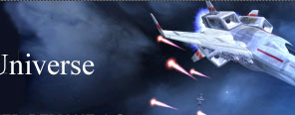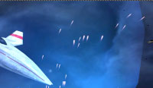
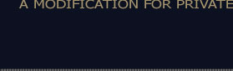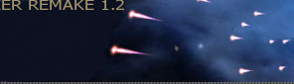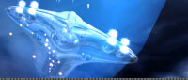

Download it at http://pu.wcjunction.com/

Future plans intend to build on the Privateer© Remake 1.2 even more, to involve an expanded Wing Commander© series and universe.

12.4.2 Manual Changes
A separate manual is provided with the game files.

12.5 Elite Strike

12.5.1 What is it?
Most importantly, Elite© Strike is a fan-made Elite© game. We have several goals in creating a new Elite game:
- To create an "Elite© Universe", where every Elite© ship from every Elite© game is playable.
- To have a version of Elite© that is able to run natively on modern systems.
- To pay homage to Elite©, the game that Vega Strike and Privateer© owe so much to.
- To have fun!
In technical terms, Elite© Strike is a modification of Vega Strike, based on the Privateer© Remake MOD. In its current incarnation, Elite© Strike is a patch which can be downloaded and extracted over an installation of Privateer© Remake 1.0, but our first official release will include a standalone installer.

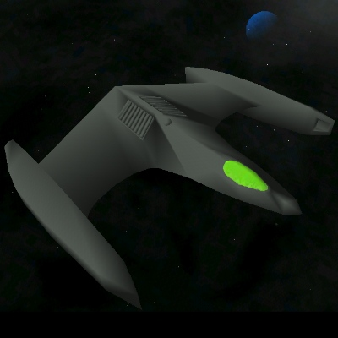

Download it at http://eliot.bambi.net/elitestrike/

12.5.2 Manual Changes
Like Vega Strike but with Elite© keybindings

12.6 Wing Commander© Armada: PI Armada

12.6.1 What is it?
PI Armada is a game designed to resemble the gameplay of the multiplayer strategy game Wing Commander©Armada©.

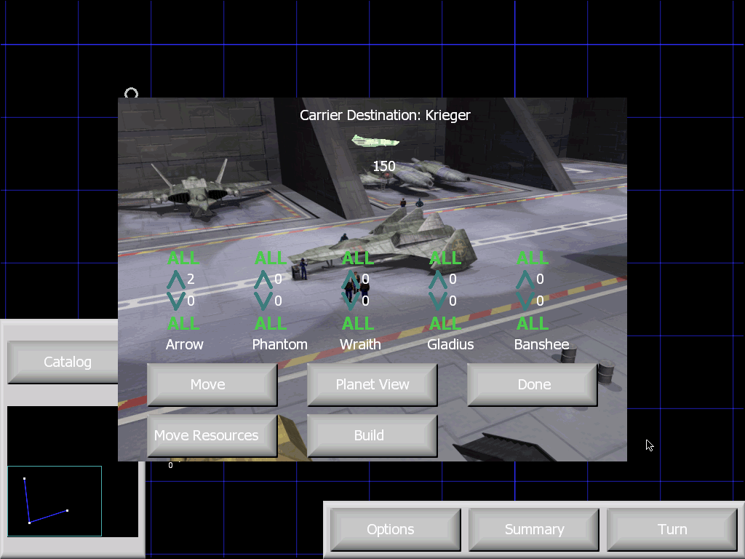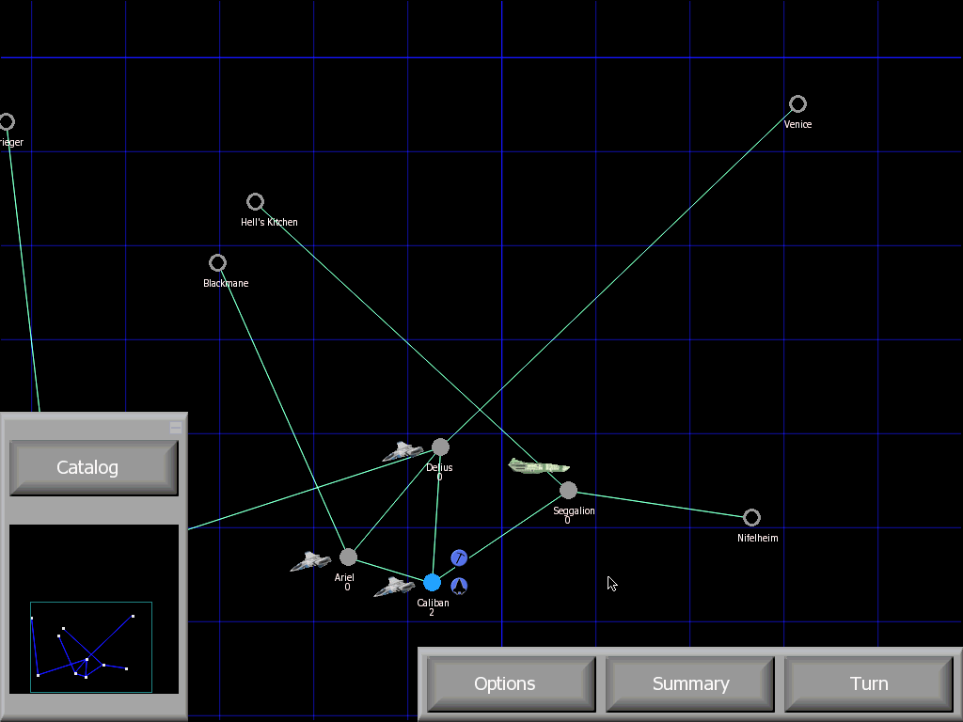

Download it at http://sourceforge.net/projects/piarmada/

Future plans intend to include multiplayer in this single player adventure.

12.6.2 Manual Changes
Combat mode is launched after strategic mode turns finish.

12.7 Vega Wars

12.7.1 What is it?
George Lucas’s © retold the classic swords and sorcery tale of a hero seeking to rescue the princess, running afoul of an evil empire, with death and glory along the way. Vega Wars will be based in © universe, including a series of missions in campaign format, and incorporating Vega Strike’s bounty hunter style of play.

12.7.2 Manual Changes
Under development, so currently Vega Strike default commands.

13. Copyright Information

13.1 Copyright
Copyright (c) 2004 Daniel Horn, Kim Scutts.
Permission is granted to copy, distribute and/or modify this document under the terms of the GNU Free Documentation License, Version 1.2 or any later version published by the Free Software Foundation; with no Invariant Sections, no Front-Cover Texts, and no Back-Cover Texts. A copy of the license is included in the section entitled "GNU Free Documentation License".
Please note that the software program Vega Strike is itself released under the GNU General Public License, a copy of which is distributed with the software files.

13.2 GNU Free Documentation License
GNU Free Documentation License
Version 1.2, November 2002
Copyright (C) 2000, 2001, 2002 Free Software Foundation, Inc.
59 Temple Place, Suite 330, Boston, MA 02111-1307 USA
Everyone is permitted to copy and distribute verbatim copies of this license document, but changing it is not allowed.
0. PREAMBLE
The purpose of this License is to make a manual, textbook, or other functional and useful document "free" in the sense of freedom: to assure everyone the effective freedom to copy and redistribute it, with or without modifying it, either commercially or noncommercially. Secondarily, this License preserves for the author and publisher a way to get credit for their work, while not being considered responsible for modifications made by others.
This License is a kind of "copyleft", which means that derivative works of the document must themselves be free in the same sense. It complements the GNU General Public License, which is a copyleft license designed for free software.
We have designed this License in order to use it for manuals for free software, because free software needs free documentation: a free program should come with manuals providing the same freedoms that the software does. But this License is not limited to software manuals; it can be used for any textual work, regardless of subject matter or whether it is published as a printed book. We recommend this License principally for works whose purpose is instruction or reference.
1. APPLICABILITY AND DEFINITIONS
This License applies to any manual or other work, in any medium, that contains a notice placed by the copyright holder saying it can be distributed under the terms of this License. Such a notice grants a world-wide, royalty-free license, unlimited in duration, to use that work under the conditions stated herein. The "Document", below, refers to any such manual or work. Any member of the public is a licensee, and is addressed as "you". You accept the license if you copy, modify or distribute the work in a way requiring permission under copyright law.
A "Modified Version" of the Document means any work containing the Document or a portion of it, either copied verbatim, or with modifications and/or translated into another language.
A "Secondary Section" is a named appendix or a front-matter section of the Document that deals exclusively with the relationship of the publishers or authors of the Document to the Document's overall subject (or to related matters) and contains nothing that could fall directly within that overall subject. (Thus, if the Document is in part a textbook of mathematics, a Secondary Section may not explain any mathematics.) The relationship could be a matter of historical connection with the subject or with related matters, or of legal, commercial, philosophical, ethical or political position regarding them.
The "Invariant Sections" are certain Secondary Sections whose titles are designated, as being those of Invariant Sections, in the notice that says that the Document is released under this License. If a section does not fit the above definition of Secondary then it is not allowed to be designated as Invariant. The Document may contain zero Invariant Sections. If the Document does not identify any Invariant Sections then there are none.
The "Cover Texts" are certain short passages of text that are listed, as Front-Cover Texts or Back-Cover Texts, in the notice that says that the Document is released under this License. A Front-Cover Text may be at most 5 words, and a Back-Cover Text may be at most 25 words.
A "Transparent" copy of the Document means a machine-readable copy, represented in a format whose specification is available to the general public, that is suitable for revising the document straightforwardly with generic text editors or (for images composed of pixels) generic paint programs or (for drawings) some

widely available drawing editor, and that is suitable for input to text formatters or for automatic translation to a variety of formats suitable for input to text
formatters. A copy made in an otherwise Transparent file format whose markup, or absence of markup, has been arranged to thwart or discourage subsequent
modification by readers is not Transparent. An image format is not Transparent if used for any substantial amount of text. A copy that is not "Transparent" is
called "Opaque".
Examples of suitable formats for Transparent copies include plain ASCII without markup, Texinfo input format, LaTeX input format, SGML or XML using a
publicly available DTD, and standard-conforming simple HTML, PostScript or PDF designed for human modification. Examples of
transparent image formats include PNG, XCF and JPG. Opaque formats include proprietary formats that can be read and edited only by proprietary word
processors, SGML or XML for which the DTD and/or processing tools are not generally available, and the machine-generated HTML, PostScript or PDF produced
by some word processors for output purposes only.
The "Title Page" means, for a printed book, the title page itself, plus such following pages as are needed to hold, legibly, the material this License requires to
appear in the title page. For works in formats which do not have any title page as such, "Title Page" means the text near the most prominent appearance of the
work's title, preceding the beginning of the body of the text.
A section "Entitled XYZ" means a named subunit of the Document whose title either is precisely XYZ or contains XYZ in parentheses following text that
translates XYZ in another language. (Here XYZ stands for a specific section name mentioned below, such as "Acknowledgements", "Dedications",
"Endorsements", or "History".) To "Preserve the Title" of such a section when you modify the Document means that it remains a
section "Entitled XYZ" according to this definition.
The Document may include Warranty Disclaimers next to the notice which states that this License applies to the Document. These Warranty Disclaimers are
considered to be included by reference in this License, but only as regards disclaiming warranties: any other implication that these Warranty Disclaimers may have
is void and has no effect on the meaning of this License.
2. VERBATIM COPYING
You may copy and distribute the Document in any medium, either commercially or noncommercially, provided that this License, the copyright notices, and the license notice saying this License applies to the Document are reproduced in all copies, and that you add no other conditions whatsoever to those of this License. You may not use technical measures to obstruct or control the reading or further copying of the copies you make or distribute. However, you may accept compensation in exchange for copies. If you distribute a large enough number of copies you must also follow the conditions in section 3.
You may also lend copies, under the same conditions stated above, and you may publicly display copies.
3. COPYING IN QUANTITY
If you publish printed copies (or copies in media that commonly have printed covers) of the Document, numbering more than 100, and the Document's license notice requires Cover Texts, you must enclose the copies in covers that carry, clearly and legibly, all these Cover Texts: Front-Cover Texts on the front cover, and Back-Cover Texts on the back cover. Both covers must also clearly and legibly identify you as the publisher of these copies. The front cover must present the full title with all words of the title equally prominent and visible. You may add other material on the covers in addition. Copying with changes limited to the covers, as long as they preserve the title of the Document and satisfy these conditions, can be treated as verbatim copying in other respects.
If the required texts for either cover are too voluminous to fit legibly, you should put the first ones listed (as many as fit reasonably) on the actual cover, and continue the rest onto adjacent pages.
If you publish or distribute Opaque copies of the Document numbering more than 100, you must either include a machine-readable Transparent copy along with each Opaque copy, or state in or with each Opaque copy a computer-network location from which the general network-using public has access to download using public-standard network protocols a complete Transparent copy of the Document, free of added material.
If you use the latter option, you must take reasonably prudent steps, when you begin distribution of Opaque copies in quantity, to ensure that this Transparent copy will remain thus accessible at the stated location until at least one year after the last time you distribute an Opaque copy (directly or through your agents or retailers) of that edition to the public.
It is requested, but not required, that you contact the authors of the Document well before redistributing any large number of copies, to give them a chance to provide you with an updated version of the Document.
4. MODIFICATIONS
You may copy and distribute a Modified Version of the Document under the conditions of sections 2 and 3 above, provided that you release the Modified Version under precisely this License, with the Modified Version filling the role of the Document, thus licensing distribution and modification of the Modified Version to whoever possesses a copy of it. In addition, you must do these things in the Modified Version:
Use in the Title Page (and on the covers, if any) a title distinct from that of the Document, and from those of previous versions (which should, if there were any, be listed in the History section of the Document). You may use the same title as a previous version if the original publisher of that version gives permission. List on the Title Page, as authors, one or more persons or entities responsible for authorship of the modifications in the Modified Version, together with at least five of the principal authors of the Document (all of its principal authors, if it has fewer than five), unless they release you from this requirement.

State on the Title page the name of the publisher of the Modified Version, as the publisher.
Preserve all the copyright notices of the Document.
Add an appropriate copyright notice for your modifications adjacent to the other copyright notices.
Include, immediately after the copyright notices, a license notice giving the public permission to use the Modified Version under the terms of this License, in the
form shown in the Addendum below.
Preserve in that license notice the full lists of Invariant Sections and required Cover Texts given in the Document's license notice.
Include an unaltered copy of this License.
Preserve the section Entitled "History", Preserve its Title, and add to it an item stating at least the title, year, new authors, and publisher of the Modified Version as
given on the Title Page. If there is no section Entitled "History" in the Document, create one stating the title, year, authors, and publisher of the Document as given
on its Title Page, then add an item describing the Modified Version as stated in the previous sentence.
Preserve the network location, if any, given in the Document for public access to a Transparent copy of the Document, and likewise the network locations given in
the Document for previous versions it was based on. These may be placed in the "History" section. You may omit a network location for a work that was
published at least four years before the Document itself, or if the original publisher of the version it refers to gives permission.
For any section Entitled "Acknowledgements" or "Dedications", Preserve the Title of the section, and preserve in the section all the substance and tone of each of
the contributor acknowledgements and/or dedications given therein.
Preserve all the Invariant Sections of the Document, unaltered in their text and in their titles. Section numbers or the equivalent are not considered part of the
section titles.
Delete any section Entitled "Endorsements". Such a section may not be included in the Modified Version.
Do not retitle any existing section to be Entitled "Endorsements" or to conflict in title with any Invariant Section.
Preserve any Warranty Disclaimers.
If the Modified Version includes new front-matter sections or appendices that qualify as Secondary Sections and contain no material copied from the Document,
you may at your option designate some or all of these sections as invariant. To do this, add their titles to the list of Invariant Sections in the Modified Version's
license notice. These titles must be distinct from any other section titles.
You may add a section Entitled "Endorsements", provided it contains nothing but endorsements of your Modified Version by various parties--for example,
statements of peer review or that the text has been approved by an organization as the authoritative definition of a standard.
You may add a passage of up to five words as a Front-Cover Text, and a passage of up to 25 words as a Back-Cover Text, to the end of the list of Cover Texts in
the Modified Version. Only one passage of Front-Cover Text and one of Back-Cover Text may be added by (or through arrangements made by) any one entity. If
the Document already includes a cover text for the same cover, previously added by you or by arrangement made by the same entity you are acting on behalf of,
you may not add another; but you may replace the old one, on explicit permission from the previous publisher that added the old one.
The author(s) and publisher(s) of the Document do not by this License give permission to use their names for publicity for or to assert or imply endorsement of any
Modified Version.
5. COMBINING DOCUMENTS
You may combine the Document with other documents released under this License, under the terms defined in section 4 above for modified versions, provided that you include in the combination all of the Invariant Sections of all of the original documents, unmodified, and list them all as Invariant Sections of your combined work in its license notice, and that you preserve all their Warranty Disclaimers.
The combined work need only contain one copy of this License, and multiple identical Invariant Sections may be replaced with a single copy. If there are multiple Invariant Sections with the same name but different contents, make the title of each such section unique by adding at the end of it, in parentheses, the name of the original author or publisher of that section if known, or else a unique number. Make the same adjustment to the section titles in the list of Invariant Sections in the license notice of the combined work.
In the combination, you must combine any sections Entitled "History" in the various original documents, forming one section Entitled "History"; likewise combine any sections Entitled "Acknowledgements", and any sections Entitled "Dedications". You must delete all sections Entitled "Endorsements".
6. COLLECTIONS OF DOCUMENTS
You may make a collection consisting of the Document and other documents released under this License, and replace the individual copies of this License in the various documents with a single copy that is included in the collection, provided that you follow the rules of this License for verbatim copying of each of the documents in all other respects.
You may extract a single document from such a collection, and distribute it individually under this License, provided you insert a copy of this License into the extracted document, and follow this License in all other respects regarding verbatim copying of that document.
7. AGGREGATION WITH INDEPENDENT WORKS
A compilation of the Document or its derivatives with other separate and independent documents or works, in or on a volume of a storage or distribution medium, is called an "aggregate" if the copyright resulting from the compilation is not used to limit the legal rights of the compilation's users beyond what the individual works permit. When the Document is included in an aggregate, this License does not apply to the other works in the aggregate which are not themselves derivative works of the Document.

If the Cover Text requirement of section 3 is applicable to these copies of the Document, then if the Document is less than one half of the entire aggregate, the Document's Cover Texts may be placed on covers that bracket the Document within the aggregate, or the electronic equivalent of covers if the Document is in electronic form. Otherwise they must appear on printed covers that bracket the whole aggregate.
8. TRANSLATION
Translation is considered a kind of modification, so you may distribute translations of the Document under the terms of section 4. Replacing Invariant Sections with translations requires special permission from their copyright holders, but you may include translations of some or all Invariant Sections in addition to the original versions of these Invariant Sections. You may include a translation of this License, and all the license notices in the Document, and any Warranty Disclaimers, provided that you also include the original English version of this License and the original versions of those notices and disclaimers. In case of a disagreement between the translation and the original version of this License or a notice or disclaimer, the original version will prevail.
If a section in the Document is Entitled "Acknowledgements", "Dedications", or "History", the requirement (section 4) to Preserve its Title (section 1) will typically require changing the actual title.
9. TERMINATION
You may not copy, modify, sublicense, or distribute the Document except as expressly provided for under this License. Any other attempt to copy, modify, sublicense or distribute the Document is void, and will automatically terminate your rights under this License. However, parties who have received copies, or rights, from you under this License will not have their licenses terminated so long as such parties remain in full compliance.
- FUTURE REVISIONS OF THIS LICENSE

The Free Software Foundation may publish new, revised versions of the GNU Free Documentation License from time to time. Such new versions will be similar in spirit to the present version, but may differ in detail to address new problems or concerns. Seehttp://www.gnu.org/copyleft/.
Each version of the License is given a distinguishing version number. If the Document specifies that a particular numbered version of this License "or any later version" applies to it, you have the option of following the terms and conditions either of that specified version or of any later version that has been published (not as a draft) by the Free Software Foundation. If the Document does not specify a version number of this License, you may choose any version ever published (not as a draft) by the Free Software Foundation.
ADDENDUM: How to use this License for your documents
To use this License in a document you have written, include a copy of the License in the document and put the following copyright and license notices just after the title page:
Copyright (c) YEAR YOUR NAME.
Permission is granted to copy, distribute and/or modify this document under the terms of the GNU Free Documentation License, Version 1.2 or any later version
published by the Free Software Foundation; with no Invariant Sections, no Front-Cover Texts, and no Back-Cover Texts. A copy of the license is included in the
section entitled "GNU Free Documentation License".
If you have Invariant Sections, Front-Cover Texts and Back-Cover Texts, replace the "with...Texts." line with this:
with the Invariant Sections being LIST THEIR TITLES, with the Front-Cover Texts being LIST, and with the Back-Cover Texts being LIST. If you have Invariant Sections without Cover Texts, or some other combination of the three, merge those two alternatives to suit the situation. If your document contains nontrivial examples of program code, we recommend releasing these examples in parallel under your choice of free software license, such as the GNU General Public License, to permit their use in free software.

14. Quick Key Guide

14.1.1 Navigation-Direction Keys
Name | Key(s) | Command | Description
Up | [CURSOR -UP]  [KP-8] | UpKey | Align thrusters up, moving nose of your ship down.
Down | [CURSOR -DOWN] [KP-2]  [KP-5] | DownKey | Align thrusters down, moving nose of your ship up.
Rotate Right | [CURSOR -LEFT]  [KP-4] | RightKey | Rotates your ship to the right.
Rotate Left | [CURSOR -RIGHT] [KP-6] | LeftKey | Rotates your ship to the left.
Roll Right | [DEL] [*] [KP-*] | RollRightKey | Roll your ship to the right.
Roll Left | [INS] [/] [KP-/] | RollLeftKey | Roll your ship to the left
Strafe Left | [<] | ThrustLeft | Strafes left
Strafe Right | [>] | ThrustRight | Strafes right
Strafe Up | [,] | ThrustUp | Strafes up
Strafe Down | [.] | ThrustDown | Strafes down
Jump Drive | [j] | JumpKey | Press this to jump to another system. You must be in range of a jump point.
Autopilot | [a] | ASAP | Activate Autopilot.
Manual SPEC | [A] | ToggleWarpDrive | Manually activate SPEC insystem FTL drive

14.1.2 Navigation-Speed/Velocity
Name | Key(s) | Command | Description
Decelerate | [-] [KP--] | DecelKey | Decrease set velocity of your ship.
Accelerate | [KP+] [=] | AccelKey | Increase set velocity of your ship.
Overdrive | [TAB] | ABKey | Trades fuel efficiency for extra acceleration.
Match Velocity | [HOME ] [KP-7] | SetVelocityRefKey | Sets your zero velocity to your target’s current velocity.
Reset Velocity | [END] [KP-1] | SetVelocityNullKey | Reset your zero velocity relative to the system’s sun.
Stop | [BACK] | StopKey | Set current velocity to zero.
Full Throttle | [\] | StartKey | Set your velocity to maximum ship capable velocity.
Inertial Mode | [ ` ] | Flight::Mode::InertialToggle | Disable flight-computer compensation

14.1.3 Sound and Music
Name | Key | Command | Description
Skip Music Track | [S] | Cockpit::SkipMusicTr ack | Skip Music Track
Sound Volume Up | [F9] | VolumeInc | Sound Volume Up
Sound Volume Down | [F10] | VolumeDec | Sound Volume Down
Music Volume Up | [F11] | MusicVolumeInc | Music Volume Up
Music Volume Down | [F12] | MusicVolumeDec | Music Volume Down

14.1.4 Communication (General/Wingmen)
Name | Key | Command | Description
Form Up Wingmen | [alt-F] | CommFormUp | Tell your wingmen to form up.
Break Wingmen Formation | [alt-B] | CommBreakForm | Tell your wingmen to stop forming up.
Help Me | [alt-H] | CommHelpMeOut | Tell your wingmen to help you. They will attack the ship(s) attacking you.
Wingman Attack Target | [alt-D] | CommAttackTarget | Tell your wingmen to attack your selected target.
Talking to other ships/stations | [F1]-[F8] | Comm1KeyComm8Key | You can talk to other ships/stations/whatever by pressing one of this buttons where the number means the aggression in your voice. 1=friendly 8=insulting
Request Docking Clearance | [alt-0] | RequestClearenceKey | Select a target you want to dock with and press this. Docking locations will become visible, and friendly ships will drop out of SPEC.

14.1.5 Target-Select
Name | Key(s) | Command | Description
All Units/Targets | Forward:[t] Backward:[T] | TargetKey ReverseTargetKey | Cycles through all targets in radar range + navigational & Capital targets.
Navigational Targets | Forward:[n] Backward:[N] | SigTargetKey ReverseSigTargetKey | Cycles through all navigational targets in current system.
Non-planetary/Nonnatural Units | Forward:[u] Backward:[U] | UnitTargetKey ReverseUnitTargetKey | Switches through all constructed (i.e. not naturally occurring) entities within radar range.
Hostile Units/Targets | Forward:[h] Backward:[H]  Nearest:[r]  Threat:[R] | NearestTargetKey ReverseNearestTargetKey  NearestHostileTargetKey  NearestDangerousHostileKey | Switches through all hostile (to you) targets within radar range.
Mission Targets | [alt-N]/[alt-n] | MissionTargetKey | Targets next mission object/waypoint
Subunit Select | [b] | SubUnitTargetKey | Switches through the subunits of currently selected target.
Lock Unit/Target | [l] | LockTargetKey | 'Lock' your selection on the selected target. This is required for autotracking to engage.
Front Targets | [p] | PickTargetKey | Selects objects in a cone in front of you (near the crosshair).

14.1.6 Combat
Name | Key(s) | Command | Description
Fire Weapon/Guns | [SPACE] | FireKey | Fires your main weapons/guns (beams/bolts/chainguns/whatever).
Select Weapon/Gun | [g] | WeapSelKey | Switches through your main weapons.
Fire Missiles/Torpedoes | [RETURN] [KP-ENTER] | MissileKey | Fires your missiles/torpedoes if your ship has some of them equipped.
Switch Missiles/Torpedoes | [w] | MisSelKey | Switches through your main missiles/torpedoes.
Combat/Flight Mode | [y] | SwitchCombatMode | Toggles Manuever/Travel modes. Velocity governors are set much higher in travel mode than in maneuver mode.
Cloaking Device | [c] | CloakKey | By pressing this key you enable/disable your Cloaking device (if you own one).
ECM Device | [e] | ECMKey | Enable/disable your ECM Device (if you own one). It will cause incoming missiles to be confused. The ECM-device will constantly draw energy from your reactor.

14.1.7 Turret(s)
Name | Key | Command | Description
Switch Turret Control | []] | TurretControl | By pressing this button you can switch to the manual control of your turret(s) (if you have one/some equipped) and switch back to cockpit control.
Target for Turret | [P] | TurretTargetKey | Select a target your turret(s) should attack. The target your turrets are attacking is surrounded by a plus sign.
Turret AI on/off/FAW | [o]/  [alt-o]/[O] | TurretAI{On,Off,FireAtWill} | Switch the AI of your turret(s) on/off/FAW. Without an AI the turret can still be controlled manually.

14.1.8 Game-Commands
Name | Key(s) | Command | Description
Toggle Quit Mode | [ESC] | Cockpit::Quit | Press [q] after [ESC] to quit the game or [ESC] again to return to game.
Pause | [ | ] [PAUSE] | PauseKey | Pause the game.

14.1.9 Camera-Control
Name | Key | Command | Description
Toggle Cockpit | [1] | Cockpit::Inside | Cycle between cockpit and HUD view.
Look Left | [2] | Cockpit::InsideLeft | View to your left.
Look Right | [3] | Cockpit::InsideRight | View to your right.
Look Back | [4] | Cockpit::InsideBack | View looking to the rear.
Chasecam | [5] | Cockpit::Behind | View from above and behind your ship.
Panning Camera | [6] | Cockpit::Pan | Provides a panning camera view of your ship. Move the camera by pressing ([q,z,s,f])
Target Camera | [7] | Cockpit::OutsideTarget | Press this to see a 3rd-person view of your selected target.
Target Panning Camera | [8] | Cockpit::PanTarget | Provides a panning camera view of your target. Move the camera by pressing ([q,z,s,f])
Zoom View In | [9] | Cockpit::ZoomIn | Zoom in on target.
Zoom View Out | [0] | Cockpit::ZoomOut | Zoom out on target.

14.1.10 Info/Mission/Cargo
Name | Key | Command | Description
Map/Info Screen | [M] | Cockpit::NavScreen | Activate/Deactivate Map screen during flight.
Left VDU | [m] | Cockpit::SwitchLVDU | Cycles through all the possible displays in your left VDU
Right VDU | [v] | Cockpit::SwitchRVDU | Cycles through all the possible displays in your left VDU
Scroll Text Up | [PGUP] [KP-9] | Cockpit::ScrollUp | Scroll selected VDU up
Scroll Text Down | [PGDN] [KP-3] | Cockpit::ScrollDown | Scroll selected VDU down
Eject Cargo | [Z] | EjectCargoKey | Ejects the selected (topmost) cargo in your cargo bay into space. Use the scroll text keys to move the appropriate cargo to the top. Useful to get rid of pirates by leaving cargo behind, hiding contraband from security ships, eject unwanted cargo, and launching fighters.

14.1.11 Miscellaneous

Name | Key | Command | Description
Ejection | [alt-E] | EjectKey | Press this key to eject yourself out of your ship sitting in an ejectpod. It has weak guns/shields and will not help you against enemy ships, but it will bring you to the next save and friendly station/ship.
Respawn after death | [;] | Respawn | Restores play to last saved position.
Self Destruct | [!] | SuicideKey | Self destruct ship and pilot death.
Chat | “]” | TextMessage | Chat for multiplayer
Activate Dock Procedure | [d] | DockKey | When sufficiently close to green docking markers, this key will activate docking procedures.
Pan Up | [q] | Cockpit::PitchDown | When panning, moves the camera up
Pan Down | [z] | Cockpit::PitchUp | When panning, moves the camera down
Pan Left | [s] | Cockpit::YawLeft | When panning, moves the camera left
Pan Right | [f] | Cockpit::YawRight | When panning, moves the camera right

